Utilization of Lime Derived From Mussel
Freshwater Shells (Pilsbryoconcha exilis) to Increase
Swamp Water pH For Catfish (Pangasius sp.) culture

Dade Jubaedah^{1,*}, Marsi², Marini Wijayanti¹, Fifi Jayanti Putri¹

¹Study Program of Aquaculture, Fisheries Department, Agriculture Faculty, Universitas Sriwijaya
²Study Program of Soil Science, Fisheries Department, Agriculture Faculty, Universitas Sriwijaya

*Corresponding Author: dadejubaedah@fp.unsri.c.id

Abstract

The water pH of swamp land is generally low (below 4) and becomes a constraint in catfish culture that requires pH 6.5-8.5. In this current study, the low pH value of water was overcome by liming using lime produced from the mussel freshwater shells. The purposes of this study were to determine the best dosage of lime derived from mussel freshwater shells to increase the pH of swamp water, as well as its effect on the survival rate and growth of catfish fingerlings. This study used Completely Randomized Design (CRD) with 5 treatments and 3 replications. The treatments used were the different dosages of lime derived from mussel freshwater shells (P1=4,000, P2=5,000, P3=6,000, P4=7,000 kg/ha equivalent CaO) and calcite (CaCO₃) as control (P5= 6,000 kg/ha equivalent CaO). The result showed that P4 was the best treatment according to data of swamp water pH increased from 3.4 to 8.23, soil pH increased from 3.4 to 8.22, survival rate (100%), absolute growth of weight (56.59 g) and length (13.37 cm) and feed effeciency (113.06%).
Keywords: lime, mussel freshwater shells, pH, soil, water,

Abstrak (Indonesian)

Lahan rawa lebak umumnya memiliki pH air rendah (di bawah 4). Faktor inilah yang menjadi kendala dalam budidaya ikan patin yang membutuhkan pH 6,5-8,5. Upaya dalam mengatasi rendahnya nilai pH yaitu dengan dilakukan proses pengapuran menggunakan bahan alternatif berupa cangkang kijing. Tujuan penelitian ini adalah mengetahui dosis terbaik kapur yang berasal dari cangkang kijing untuk meningkatkan pH air rawa, pengaruhnya terhadap kelangsungan hidup dan pertumbuhan benih ikan patin. Penelitian ini menggunakan Rancangan Acak Lengkap (RAL) dengan 5 perlakuan dan 3 ulangan. Perlakuan yang digunakan yaitu perbedaan dosis kapur cangkang kijing (P1=4.000, P2=5.000, P3=6.000, P4=7.000) kg/ha setara CaO dan kalsit (CaCO₃) sebagai kontrol (P5 =6.000) kg/ha setara CaO. Hasil penelitian menunjukkan P4 merupakan perlakuan terbaik yang mampu meningkatkan pH air rawa dari 3,4 menjadi 8,20; pH tanah dari 3,4 menjadi 8,16, dan menghasilkan kelangsungan hidup 100%, pertumbuhan bobot mutlak 12,66 g, pertumbuhan panjang mutlak 6,87 cm serta efisiensi pakan
114,93%.
Kata kunci: air, kapur, kijing, pH, tanah

- Introduction
Soil’s and water’s pH value in swamp area becames a basic problem for aquaculture development in this area. Problem with acid-base relationship in ponds ussually can be solved by liming. The liming materials most frequently used is agricultural limestone i.q. calcite(CaCO₃), dolomite (CaMg(CO₃)₂ or some blend of these two substances.The others are calcium hydroxide (Ca(OH)₂) and calcium oxide (CaO) [1]. Liming materials derived from domestic waste and by-product are used as an alternative of those kind materials. The waste ashes comes from food scarp, animal waste, horticulture sewage and incinerator bottom from various locations in Japan can be used as liming agents on acid soil [2].
Based on some reseach proven that shells of Anadara granosa [3] and Pomacea canaliculata [4] have increase the soil’s and water pH of catfish ponds. Another shells that potentially used is mussel freshwater shells (Pilsbryoconcha exilis). Mussel freshwater shell size <90 mm and >90 mm have calcium contain 39.55% and 28.97%, respectively. Pyrolysed mussel shells are viable alternative raw material source for producing lime calcium oxide (CaO) [5]. Based on pre-research, mussel frehwater shells contain CaO 60.33% and MgO 19.82% Therefore, these shells potentially used as lime materials for increase soil’s and water’s pH value.

- Experimental Section

  - Materials
Materials that used in this research were mussel freshwater shells, calcite, catfish, soils and water’s swamp. The instruments were fish ponds (1 x 1 x 1 m³), sieve 60, 42.5 and 30 mesh, furnace, and water quality instruments. The water pH was measured by using a portable pH meter. The water temperature was observed by using a digital handy thermometer. The analytical determinations of total alkalinity and total ammonia were carried out according to the guidelines presented by APHA [6]. Total ammonia was analyzed by using spectrofotometer, and alkalinity using titration equipments.

  - Method
    - Sample collection and preparation
For preparing of lime, mussel shell was colected from Belitang, Ogan Komering Ulu, South Sumatera Indonesia. The sample were washed and air-dried, then activated by burned using furnace at temperature 800ºC for one hours and sieved. Swamp soils was air-dried and sieved using 10 mesh of sieve and placed on each pond with 15 cm height. Lime was spread and stirred homogeniously on soil, then incubated for 7 days at field capacity soil moisture. Soil’s pH was measured daily at these times. Swamps water was filled to the ponds with 500 L volume for each ponds and equilibrated for 3 days. Waters’s pH was measured daily at these times.

    - Fish Culture

Fish that was acclimated for one week, stocked to the ponds at 10 days after liming. The fish fed to satiation three times per day with artificial diet containing 30% protein. The water quality variables e.q. dissolved oxygen, ammonia, alkalinity and hardness were measured and analized, as well as growth of fish was measured every 20 days. Meanwhile, pH and temperature was measured daily.

    - Experimental variable and analytical procedurs

Water quality, survival and growth performance variables were observed in the present work. Water quality, survival and growth performance results were statistically analyzed according to the two-way Anova to detect if there was any significant influence due to experimental treatments. When the influence was at least significant, the means were compared using Dunnett test with P5 as control for P1, P2, P3 and P4. The 5% significance level was adopted in all statistical analysis.

2.2.4. Data Analysis
The fish survival rate was calculated from the initial number of fish and mortality after the experiment was completed. The absolute growth of fish were determined from the mean of initial and final weight and length of fish, respectively for absolute weight growth and length growth. Meanwhile, feed efficiency was calculated by the formula of NRC [7].

- Results and Discussion

Soil’s pH was increase in the incubation time and fish culture (Table 1 and 2). Based on statistical analysis (Table 1 and 2), soil’s pH in the final day of incubation and fish culture showed that dosage 4 ton/ha and 5 ton/ha lime derived from mussel shell (P1 and P2) was lower significant different than calcite 6 ton/ha. In the same dosage of lime (6 ton/ha), mussel shell lime (P3) and calcite (p5) was unsignificat difference, but higher dosage of mussel shell lime (7 ton/ha) (P4) has highest soil’s pH and significant difference with calcite (6 ton/ha).

Table 1. Dunnett analysis result for soil’s pH at incubation time
Treatments | Soil’s pH at day
 | 0 | 1 | 2 | 3 | 4 | 5 | 6 | 7
P1 | 5,93* | 6,17* | 6,45^{tn} | 6,48* | 6,65* | 6,77* | 6,96* | 6,98*
P2 | 6,20* | 6,51^{tn} | 6,55^{tn} | 6,64* | 6,77^{tn} | 6,92* | 7,16^{tn} | 7,39*
P3 | 6,26* | 6,64* | 6,76* | 6,79^{tn} | 6,95* | 6,98^{tn} | 7,33* | 7,63^{tn}
P4 | 6,38^{tn} | 6,82* | 6,86* | 7,16* | 7,22* | 7,51* | 7,56* | 7,75*
P5 | 6.38 | 6.51 | 6.52 | 6.77 | 6.81 | 7.03 | 7.07 | 7.65
D_{0.05} | 0.068 | 0.0481 | 0.0817 | 0.0644 | 0.1259 | 0.0924 | 0.0924 | 0.0518
*) : significant difference with control (P5), tn : unsignificant difference with control (P5)

Table 2. Dunnett analysis result for soil’s and water’s pH at 0, 20, 40 and 60 days fish culture
Treatment | Soil’s pH at day |  |  |  | Water’s pH at day
 | 0 | 20 | 40 | 60 | 0 | 20 | 40 | 60
P₁ | 6,98* | 7,16* | 7,25* | 7,27* | 6,85* | 7,35* | 7,50* | 7,51*
P₂ | 7,49* | 7,66* | 7,75* | 7,77* | 7,26* | 7,71* | 7,96* | 7,97*
P₃ | 7,63^{tn} | 8,02^{tn} | 8,03^{tn} | 8,04^{tn} | 7,53^{tn} | 8,11^{tn} | 8,16^{tn} | 8,18^{tn}
P₄ | 7,77* | 8,07* | 8,17* | 8,22* | 7,76* | 8,12^{tn} | 8,20* | 8,23*
P₅ | 7.67 | 7.98 | 8.03 | 8.07 | 7.52 | 8.06 | 8.15 | 8.16
D_{0,05} | 0.0535 | 0.0666 | 0.025 | 0.0354 | 0.0707 | 0.1018 | 0.0263 | 0.0278
*) : significant difference with control (P5), tn : unsignificant difference with control (P5)

Relationship between between day of culture and soil’s and water’s pH showed that at the same dosage (6 ton/ha), mussel shell lime that was activated become CaO was increasing pH faster than calcite. The calcium carbonat (calcite) is a safe but slow-acting product, menawhile the calcium oxyde fast-acting product for aquaculture liming [8]. Based od neutralzing value (the relatfve abilities of liming materials to neutralze acidity), pure calcium carbonate is 100%. Meanwhile the NV of calcium oxide relative to the calcium carbonate standard is 179% [1].
According to equations shown in Fig. 1, the maximum pH and days after lime application to reach maximum water pH can be calculated. The maximum water pH and when it is were 7.58 at 49 days after liming, 7.95 at 48 days after liming, 8.35 at 51 days after liming, 8.32 at 53 days after liming and 8.29 at 50 days after liming, respectively for P1, P2, P3, P4 and P5. The highest maximum water pH among treatments was observed on P3 (6 ton/ha lime derived from mussel shells) with maximum pH value 8.35. This water’s pH higher than calcite on the same dosage. Furthermore, based on the equations (Fig 1) and minimum water pH (6.5) for optimal growth of Pangasius sp, the next lime application should be considered after day, 109th and 118th , 130th, 148 th and 128 th for P1, P2, P3, P4 and P5, respectively

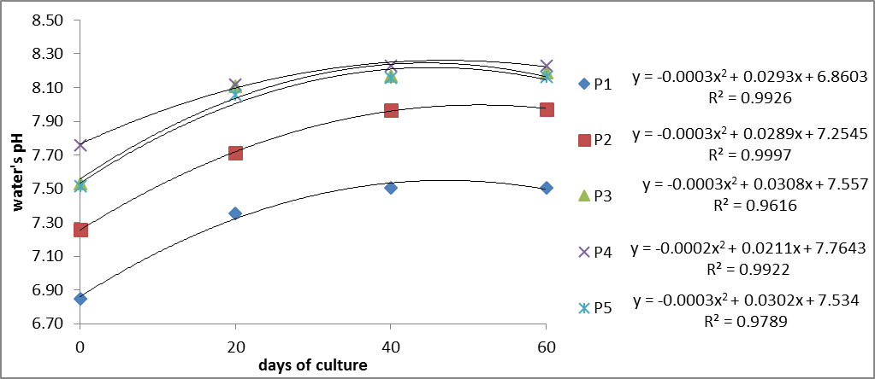
Fig. 1. Relationship between days of culture and water’s pH

The water alkalinity increased with increasing of dosage of lime (Fig. 2), eventhough at final day the alkalinity of ponds that using mussel shell lime showed unsignificant dfference with calcite (Table 3). Highest alkalinity was shown at P4 ( liming with 7 ton/ha lime derived from mussel shells).

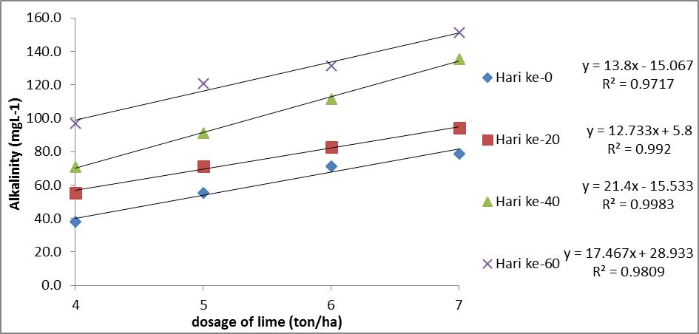
Fig 2. Relatonship between dosage of lime and alkalinity

Table 3. Dunnet test result for Alkalinity of water
Treatments | Day-0 | Day-20 | Day-40 | Day-60
P1 | 38,00* | 55,33* | 70,67* | 96,67*
P2 | 55,33* | 71,33* | 91,33* | 142,67*
P3 | 71,33^{tn} | 82,67^{tn} | 111,33* | 171,33*
P4 | 78,67* | 94,00* | 135,33* | 202,00*
P5 | 68.67 | 79.33 | 99.33 | 157.33
D_{0,05} D_{0,05} | 6.07 | 4.17 | 5.31 | 2.75
*) : significant difference with control (P5), tn : unsignificant difference with control (P5

The water temperature and dissolved oxygen (DO) of ponds (Fig 3) ranged from 27.03 to 32.17 ⁰C and from 5.20 to 6.77 mg L⁻¹, respectively. All treatment showed that the ammonia concentration increased in the final day of research (day 60th of culture) (Fig. 4). The water temperature and dissolved oxygen of the ponds remained within the appropriate range for normal growth of juvenile Pangasius sp [9] ranging from 27ºC up to 30ºC for temperature and > 5 mg L⁻¹ for dissolved Oxygen. No significant effect of lime application on dissolved oxygen at the end of rearing period was detected. Some data of temperatures exceeded the optimal value, and there were some of data DO less than optimum range but still in tolerance range for Pangasius sp. culture.

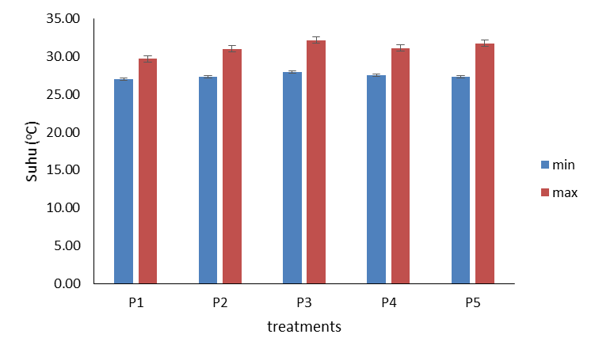 | 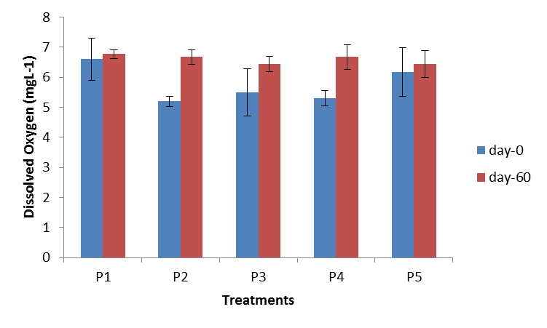
Fig. 3. Temperature (maximum and minimum) and dissolved oxygen at day-0 and day-60
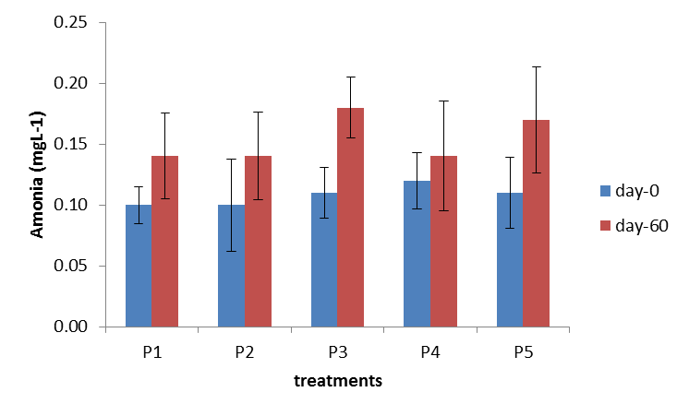
Fig. 4. Ammonia concentration in the initial (day 0 of culture) and final (day 60 of culture)

Table 4. The survival, growth and feed efficiency of catfish
Treatments | Variable
 | Survival (%) | Absolute growth of weight (g) | Absolute growth of length (cm) | Feed eficiency (%)
P1 | 96 | 27.77 | 10.13 | 108.33
P2 | 100 | 38.77 | 11.18 | 111.66
P3 | 100 | 45.84 | 12.26 | 111.85
P4 | 100 | 56.59 | 13.37 | 113.06
P5 | 100 | 44.48 | 11.93 | 110.54

The survival rate for all treatments was 96-100% (Table 4). The highest absolute growth and feed efficiency was achieved on P4 ( lime derived from mussel shell 7 ton/ha equivalent to CaO (Table 3]4). The high survival rate indicates that the water pH is within the tolerant or optimal values of pH for Pangasius sp. Growth. Based on Dunnett test showed that lime derived form P. canaliculata dosage 7 ton/ha was unsignificant different with calcite dosage 6 ton/ha to survival, growth rate and feed eficiency.

- Conclusion
Liming materials freshwater mussel shells potential to be an altenative lime for catfish swamp ponds. In the same dosage of lime (6 ton/ha), mussel shell lime and calcite was unsignificat difference, but higher dosage of mussel shell lime (7 ton/ha) (P4) has highest soil’s and water’s pH. The difference dosage of mussel shells and calcite has no significant difference for data of final day (day-60) of alkalinity, temperature, dissolved oxygen and ammonia. Survival rate, fish growth and feed eficiency at mussel lime has no significant difference among treatments.

Acknowledgement

We would like to thank Institute for Research and Community Services, Sriwijaya University that had funded this study through Competetive Grant 2017.

References
[1] C.E. Boyd. Water Quality in Ponds for Aquaculture. Alabama, Birmingham Publishing Co, 1990, pp. 195-227.
[2] F.S. Zhang., S. Yamasaki and M. Nanzyo. “Waste ashes for use in agricultural production : I. Liming effect, contents of plant nutrients and chemical characteristics of some metals”. The Science of the Total Environment, vol. 284, pp. 215-225, 2002
[3] D. Jubaedah, Marsi, R. R. Rizki. “Utilization of Anadara granosa as a Liming Materials for Swamp Fish Ponds for Pangasius sp Culture
[4] D. Jubaedah, M. Wijayanti, Marsi, N. Rizaldy.” Utilization of Golden Apple Snail (Pomacea canaliculata) shells as Liming Materials for Pangasius sp Culture in Swamp Fish Pond, in Proc. Sricoenv, 2018, in press.
[5] A. Abeynaike, L. Wang, M.I. Jones and D.A. Patterson. “Pyrolysed powdered mussel shelss for eutrophication control : effect of particle size and powder concentration on the mechanism and extent of phosphate removal”. Asia-Pacific Journal of Chemical engineering, vol. 6, pp. 231-243, Feb. 2011.
[6] APHA (American Public Health Association). “Standard Methods for the Examination of Water and Wastewater, 22nd Edition”. Washington D.C., American Water Works, 2012, 541 pp.
[7] National Research Council (NRC)., 1977. Nutrient Requirements of Warmwater
Fishes. Washington DC: National Academy Press.
[8] M.K.B., Nobre, F.R.D.S. Lima, F.B. Magalhaes and M.V.D. E Sa. “Alternative liming blends for fish culture”. Acta Scientiarum. Animal Sciences, vol 36, pp. 1-11.
[9] SNI (Standar Nasional Indonesia).. Produksi benih ikan patin siam (Pangasius hypopthalmus) kelas benihsebar. Jakarta., 2000, pp, 1-11.

