FINDING POLICIES OF DISGUISED UNEMPLOYMENT ARRANGEMENT: Through Various Technological Innovation Of Agriculture
and Income Diversification For Tidal Rice Farmer

Dessy Adriani and Elisa Wildayana
Faculty of Agriculture, Sriwijaya University

Abstract
The ecological constraint of tidal lands necessitates agricultural innovation in the related area. But technological innovation, however, make the disguised unemployment worsen in tidal land. Income diversification is expected to be a solution to the rising number of disguised unemployment-associated agricultural innovation. Both combined will offer a solution to cope with the issue of disguised unemployment. This study is aimed to analyzing strategies used to cope with disguised unemployment in the tidal agricultural sector through a combination of technological innovation and income diversification. The study was carried out in the tidal lands in Province of South Sumatra, Indonesia in 2017. This study employed a quantitative method with a survey technique. Simple random sampling was conducted to determine each subject population.The analysis was carried out using tabulative, mathematical, and simulation method. Technological innovation in agriculture gave to the rising number of disguised unemployment in tidal agriculture sector. But, with technological innovation and income diversification, disguised unemployment will be decreased and farmers' income will be increased, yet, the productivity will be low. In other words, to cope with the issues of disguised unemployment, technological innovation in the agricultural sector should be accompanied with the income diversification. However, we should be noted that the combination of agricultural technology innovation policy and income diversification affects to decreasing on household productivity The results are, by and large, useful for policy makers in designing in arranging disguised unemployment policies.

Key Words: disguised unemployment, diversification, technology, agriculture, tidal

Background
It has been firmly believed for many decades that only innovative countries will achieve high performance in economic development. The same is true with the tidal agriculture in which the agricultural technology innovation is a prerequisite (Lakitan, 2013; Villano et al., 2015; Ferrara, G., 2017). However, the application of technological innovation gives rise to issues concerning employment as it decreases the need for labor and creates disguised unemployment in rural areas (Vosko et al., 2013; Adriani, 2015; Adriani, et al., 2017). The use of technological innovation engenders longer span of unemployment, which contributes to the lower income farmers derive from the agricultural sector (Norsida, M., & S. I. Sadiya a, 2009; Wildayana and Armanto, 2018). This issue is even more compounded by the majority of agricultural reinvestment made to develop industries with capital-intensive technology (Galluzzo, N., 2017).
But some studies show that technological innovation has both negative and positive effect on the people in an area. The use of technology can enhance productivity and income simultaneously (Norsida Man & Sami Ismaila Sadiya, 2009; Wildayana, et al., 2017; Adriani, et al., 2017). In contrast, success in developing indigenous technology is relatively uncertain and will require a period of time. Secondly, most of technology develops in Indonesia have not been able to prove their full commitment to develop economically competitive and technically reliable technology. This leads to the lower demand of human labor and rising unemployment particularly in the agricultural sector due to the application of technological innovation (Lakitan, 2013; Adriani, 2017).
Technological innovation hence contributes to the uneven distribution of the farmer labor potential in the agricultural sector. Such situations as these take place in developed countries and particularly in small farms where jobs are found to be lacking (disguised unemployment) yet it is not unemployment in the pure sense. The amount of time left over after agricultural activities are done is used for non-agricultural activities. This is what is called Income Diversification. This is in line with argument made by Adriani (2015) and Adriani et al., (2017) that income diversification pertains to the economic rationality of farmer households based on social rationality that occurs. Research conducted by Ellis, Frank (1999; 2008) on Income Diversification was carried out in a more detailed. By relating the incidence of Income Diversification to disguised unemployment, disguised unemployment should be controllable by income diversification. Income diversification, as a form of social reorientation will serve as a way to maximize use of the remainder of the work time. This income diversification surely does not have an economic effect on the income. The productive economic activities that households engage constitute the application of opportunities that present themselves for income diversification.
Diversification of livelihoods in rural areas is defined as the process of households’ constructing diverse activities and social support capabilities for survival and the enhanced standard of living. The inclination of rural households to engage many jobs is frequently discussed. Yet, little is the attempt made to systematically link such behaviour to disguised unemployment mitigation policy is. The investigation into the formulation of policies to cope with the technological innovation-caused disguised unemployment is necessary to assess the role of off-farm economic activities in making best use of the leisure time and increasing income to enhance the societal welfare and the quality of life in a sustainable way. This research is importance in refining policies in terms of unemployment in order to yield optimum benefits for the sustainable economic development of farmer households in the tidal area. Moreover, this research is crucial and worth consideration as the input for the government, society, and relevant institutions in the future in addition to attention paid to the management of the farmer's household labor from socio-economic aspects. Based on the background elaborated above, this research is aimed to finding strategies to deal with disguised unemployment through a combination of technological innovation and income diversification.

Material and Methods
The research was conducted from May to December 2017. Quantitative approach was used with survey technique. The sampling method selected was proportionate Stratified Random Sampling Method based on 4 agricultural technological innovations and 1 control population as seen in Table 1.

Table 1: The Process of Sample Determining
No | Location | Population characteristics | Population  (Household) | Sample  (Household)
1. | Telang Sari Village, District of Tanjung Lago, Regency of Banyuasin | - (1) Technological innovation in the form of Rice-Corn Cropping Index (IP 200), (2) Other on farms and off-farm economic activities  - (1) Technological innovation in the form of Farming mechanization (Combine Harvester) , and (2) Other on farms and off-farm economic activities | 200  356 | 36 (18.00 %)  60 (18.86 %)
2. | Sako Village, District of Rambutan, Regency of Banyuasin | - 1) Technological innovation in the form of UPSUS Pajale for Paddy and (2) Other on farms and off-farm economic activities  - (1) Technological innovation in the form of certified rice seed production and (2) Other on farms and off-farm economic activities | 260  65 | 40 (15.38 %)  39 (60.00 %)
3. | Sungai Baung Village, District of Rawas Ulu, Regency of Musi Rawas | Not applying special technological innovation, but applying other on farms and off-farm economic activities (Control Variables) | 202 | 36 (17.82 %)
 |  | TOTAL | 1083 | 211 (19.48 %)

The analysis was conducted using tabulative, diagrammatic and simulative method on the the potential variables, allocation of working time, costs, revenues, and household income. Moreover, this study organized solutions to disguised unemployment in rural areas. Diverse technologies and the opportunities afforded to carry out income diversification serve as alternatives to deal with the issues of disguised unemployment. To strengthen the research result, the researcher conducted a Focus Discussion Group (FGD) to identify as much information as possible in terms of the opportunities to cope with disguised unemployment in the tidal area.

Result and Discussion

- Investigating into the Disguised Unemployment Cases in the Tidal Area from the Technological Innovation and Income Diversification Aspects

Disguised unemployment is an unsolve problem which both the national government in general and the regional government in particulars are confronted with and struggling to cope with. Various researchs have been taken to address the problems yet to no avail. Disguised unemployment itself arises from discrepancy between labor demand and labor supply. This problem is worth attention because the disguised unemployment potentially gives rise to various forms of vulnerability to crimes, social, political and poverty upheavals in the future.
Adriani (2015) argued that the attempts to cope with disguised unemployment in Indonesia have focused on improving the economic structure transformation from the agricultural sector to industry at a macro level without taking into account of the micro-analysis aspect. Macro analysis is certainly beneficial. Improvements at the macro level, however, will not bring about the decreasing of disguised unemployment in a much. Microanalysis is deemed effective to solve the issues of disguised unemployment because analysis is grounded on the behaviour of social and economic rationality (socio-economic rationality).
Figure 1 displays the effect various agricultural technology innovations on the household disguised unemployment in tidal area. Each kind of technological innovation has a distinct impact. Technological innovation in the form of certified rice seed production increases the allocation of working time and decreases disguised unemployment that is inversely proportional to application of other technologies. Others basically decrease the work time allocation and increase disguised unemployment in the tidal area. In comparison to other factors, technological innovation in the form of UPSUS Pajale for Paddy considerably contributes to the highest decreasing of time work allocation. This is due to full application of technology of the UPSUS Pajale program by the government (application of integrated crop farming coupled with the mechanization simultaneously).
So, it can be inferred that the general use of technology in tidal land affects the working time allocation and thus boosts the disguised unemployment. The government hence should be discreet in selecting the observable type of agricultural technology particularly to be used in tidal land. The technology used for the agricultural sector should be the labor intensive one instead of capital intensive technology.

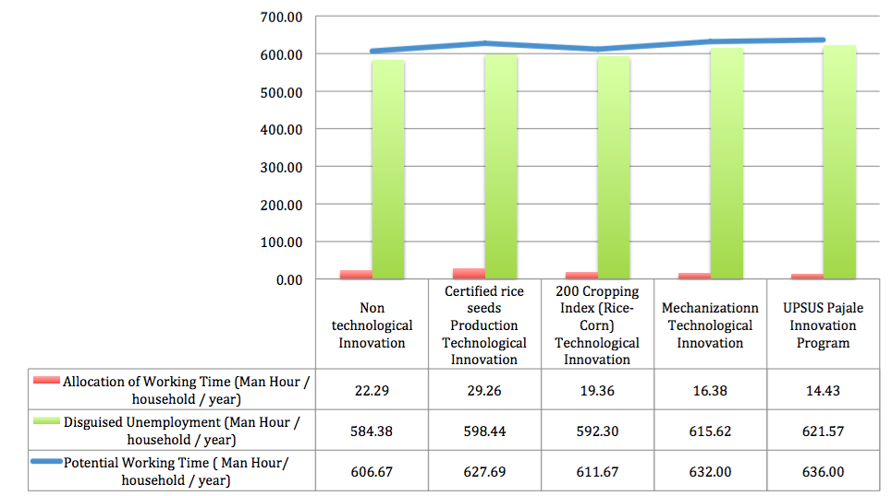
Fig 1: Detailed comparisons between potential working time, allocation of working time, and disguised unemployment for households applying and not applying various technological innovation in tidal area.
However, one thing of interest is that the less amount of working time allocated by farmers’ households affects the possible increase of disguised unemployment for households which applying technology. To compensate for the less work time allocated for rice farming, households carry out work activities outside of rice farming and outside agriculture. According to Norsida, M., & S. I. Sadiya (2009); H. Meert , et al. (2005), the factors affecting off-farm labor engagement comprise total allocation of work time and labor in the family. The less work time allocated for farming activities done by farmer households the greater is the amount of time devoted to off-farm activities that the off-farm working time is negatively linked to the working time allocated for rice farming. But this is opposed to the finding of Adriani et al., (2017) which indicated a positive relationship between the farming and the work time allocated there to. Such a case as this relates to the low allocation of time for farming that both (on farm and off farm activities potentially increase with the use of technological innovation.
Farmer household members usually engage in a rice farming activity together. In terms of the amount of time allocated for farming activities the quantity of productive assets the household members have such as the area of the land or other productive capitals is a determinant. The more the assets they have, the greater amount of time they spend working on activities that demand huge labor such as cultivating land, planting, clearing and harvesting. When they are not occupied, many members of the household set their time aside for productive activities both in the agricultural sector and other sectors to earn extra income for the family. This is in line with Sarah (2015) and Batool et al., (2017).
The results of this study show that it was not only due to the push factors such as smaller fraction of time allocated for farming sector but also the interaction of the push-pull factors of the off-farm activities. The shift occurs in terms of the working time from on farm to off-farm activities. Some of the push factors comprise: (a) shift in the mental attitude of the labor toward modernization as the enhanced level of education and social status make the farming activities less appealing and (b) the fixed amount of wages from farming labor tend to be dwindling. Whereas some of pull factors enticing workers away from the farming and rural sectors toward the non-farming sector encompass (a) off-farm job opportunities are increasing, (b) working in non-farming sector is relatively more comfortable, (c) wages rate are more certain and greater, (e) open communication / accessible transportation in rural areas offer support.
The implementation of income diversification elevates the amount of work time allocated by farmer household. In terms of the portion, the work time allocated to income diversifications (1) 92.62% for non-technology application, and (2) 81.76% for technology application. While the working time allocated for rice farming is only (2) 7.38% for non-technology applications, and (2) 18.24% for technology application. Income diversification constitutes a crucial and rational decision made by farmer households even though not all farmer households show willingness to put it into practice. Having limited resources, vulnerable households or those without alternative income will be compelled to choose between rice monoculture and diversified practice. This concurs with the statement made by H. Meert , et al. (2005)) that if farming activities provides low income to satisfy their needs, non-farming income generating sources are needed. Thus, the income diversifications are response to the vulnerability of the household economy and a strategy for survival.
Figure 2 explained comparisons between potential, work time allocation, and disguised unemployment for households applying and not applying technology followe by income diversification in tidal area. Graphically, the application of technology and income diversification implemented by farmers’ households result in the falling rate of disguised unemployment in the tidal area is obvious.
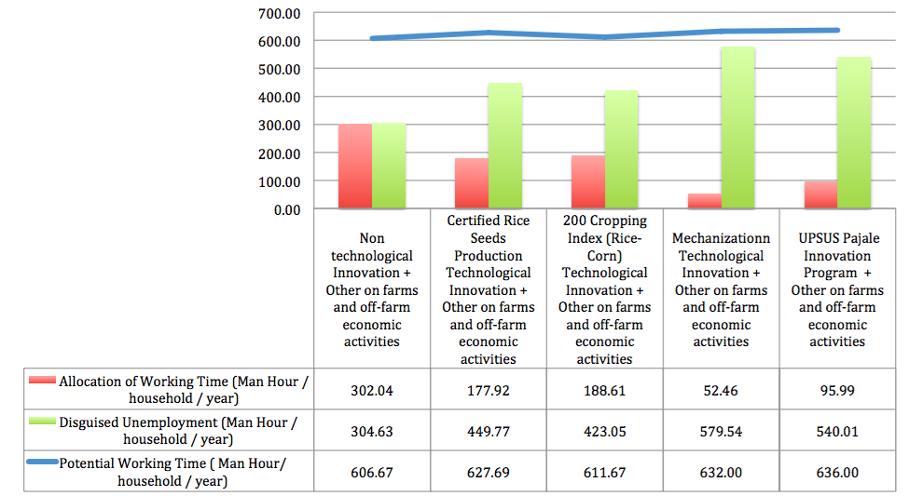
Fig 2: Detailed comparisons between potential, work time allocation, and disguised unemployment for households applying and not applying various technological innovation and income diversification in tidal area.
Figure 3 explained detailly a comparison of disguised unemployment cases between households applying and non-applying farming technologies coupled with income diversification. It is cases, when the farmer household resorts to the mere use of farming technology innovation, the high rate of disguised unemployment remains occasioned by the less amount of working time allocated due to the utilization of technology. Whereas, if the use of farming technology is coupled with income diversification, so it lead to the reduced disguised unemployment. The results of this study are relevant to the fact that the non-farming activities help reduce unemployment, create supplementary income, and provide a safety net and alleviate poverty among households. The study recommended that improved road access, access to credit and education should be to elevate participation in non-farm activities (Ibidapo I., et al., 2017). In line with the research findings of Batool et al., (2017), the dwindling labor absorption of farming sector due to mechanization, deteriorating climatic conditions and altered land distributions leads to questioning the conventional wisdom of agriculture as the sole driver for the growth of rural economy. Engagement in other non-farm activities is seen as a survival strategy in this case, especially for the poor. For well-off households in rural areas, constructing a diversified portfolio of income generating activities is a deliberate investment made in exchange for higher returns through increasing urbanization, market liberalization and development of facilitating policies.
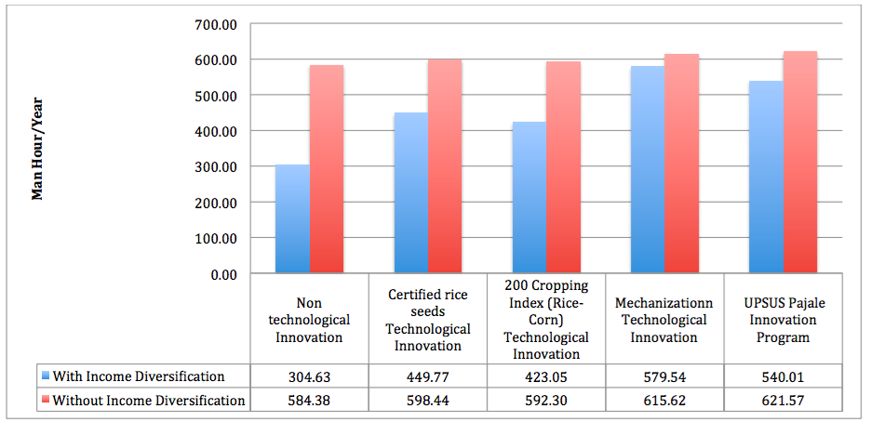
Fig 3: Comparisons between the disguised unemployment for households applying and households not applying various technological innovation coupled with income diversification in tidal land.

FINDING POLICIES FOR DISGUISED UNEMPLOYMENT

Ecological issues of tidal areas that are very dependent on climatic conditions cause technological innovation as a necessity (Lakitan, 2013; Wildayana, 2017; Wildayanan et al., 2017). It, however, certainly affects the allocation of working time for the agricultural sector and disguised unemployment. Therefore, the application of technology innovation should go together with income diversification. Adriani (2015); Johny et al., (2014) argued that farmers have economic rationality due to the lower income they earn from rice farming which furthers the development of social rationality through diversified work structures and laborers in farmer households. Diversification positively affects disguised unemployment and increases income. This study analyses a combination of technological innovation and income diversification as an alternative that is badly needed in tidal land.
Tables 2 through Table 5 quantitatively indicate how the use of technology and income diversification impacts the disguised unemployment, allocation of working time the farmer household’s income and productivity. The analysis results in some interesting findings. The use of agricultural technology without income diversification has led to disguised unemployment increase in the agricultural sector. However, the results of analysis conducted in Tables 2 through Table 3 show that the concurrent adoption of technology and income diversification lead to the reduced rate of disguised unemployment in the agricultural sector by 16.02% and increased amount of work time allocation by 477.50%. Moreover, in terms of income impact analyzed the utilization of technology helps increase income made by the farmer's household by an average of 362%. However, income diversification together with the use of technology contributes to the increase of household income by 552%.
The use of technology serves (1) to negatively increase disguised unemployment rate of 3.87%, and reduce the work time allocated by 10.91%, and (2) has a positive effect on increasing income and household productivity by 362% and 388%. Additionally, the concurrent use of technology and income diversification in the agricultural sector will lower the rate of disguised unemployment rate by 1.83% and increase the amount of work time allocated by 54.63%, income by 488%, and productivity by 243%. Moreover, the use of technology coupled with income diversification both in agriculture and non-agriculture sector serves to reduce the rate of disguised unemployment by 16.02%, increase the amount of work time allocated by 477.59%, income by 22%, and productivity by 17% .
The results of this study indicate that the issue of disguised unemployment in rural areas can be coped with by adopting policies on the combined use of agricultural technology and farming and off-farm income diversification. Hence, nearly all households observed have diversified farming income and off-farm income. The positive impact of technological advance adopted in agriculture and income diversification increase the allocation of working time, reduce disguised unemployment, and generate income and livelihood for rice farmers' households in sub optimal land. Factors which have positive and significant effects on farmers' use of technology and diversification comprise on-farm income, off-farm income, and age. Therefore, the use of technology and income diversification proves to be one of the positive scenarios for sustainable livelihoods of farmers in sub-optimal land (Adriani et al., 2017).
According to Ellis (2008), household income diversification strategy starts off with the process of constructing a variety of businesses and carrying out social cooperation in attempt to survive and improve their standard of living. Based on this research result, income generating sources in accordance with encompass as follows: 1) primary produces of farming, livestocks, forestry, fisheries or fish caught including farming labor wages, crops selling and farming produce consumption; 2) Non-farming activities in terms of off-farm income-generating activities such as mining, processed products, public services, development, trading, transportation, government employees; 3) wages earned from working for employers; 4) self-employment earnings; 5) off-farm income generating activities outside the domicile; 6) Non-farming income outside domicile. Low income society usually puts into practice income diversification that it is deemed a survival strategy. This corresponds with the research conducted by Sarah (2015).
Access to public assets such as roads as well as private assets such as education and credit constitutes an important factor in income diversification and important reason for income diversification. By gaining increased access to these assets self-reliant businesses as well as wages derived from off-farm businesses will increase. Conversely, damaged road and distance to get to education centers and financial markets affect the possibility of doing income diversification. This is consistent with Escobal’s argument (2001). Culas and Mahendrarajah (2005) analyses farm diversification in Norway using qualitative and quantitative variables. Qualitative variables driving diversification comprise location, access to capital loans, and farming organizations, whereas the quantitative variables encompass land area, experience (age), health and insurance expenditure.

Table 2: The Impact of farming technology innovation and income diversification on the disguised unemployment in the tidal area in 2017
Criteria | Without technology (ManHour/year) | With agricultural technology |  |  | With the use of technology and farming income diversification |  |  | With the use of technology and farming and non-farming income diversification
 |  | Amount (ManHour/  year) | Change |  | Amount (ManHour/year) | Change |  | Amount (ManHour/  year) | Change
 |  |  | Total change | % |  | Total change | % |  | Total change | %
Certified rice seeds Technological Innovation | 584.38 | 598.44 | 14.06 | 2.41 | 551.32 | -33.06 | -5.66 | 428.75 | -155.63 | -26.63
200 Cropping Index (Rice-Corn) Technological Innovation | 584.38 | 592.30 | 7.93 | 1.36 | 585.81 | 1.44 | 0.25 | 439.08 | -145.30 | -24.86
Mechanization of Technological Innovation | 584.38 | 615.62 | 31.24 | 5.35 | 569.62 | -14.76 | -2.52 | 559.21 | -25.17 | -4.31
UPSUS Pajale Innovation Program | 584.38 | 621.57 | 37.19 | 6.36 | 587.91 | 3.54 | 0.61 | 536.01 | -48.36 | -8.28
Average | 584.38 | 606.98 | 22.60 | 3.87 | 573.67 | -10.71 | -1.83 | 490.76 | -93.61 | -16.02

Table 3: The Impact of farming technology innovation and income diversification on the allocation of working time in the tidal area, 2017
Criteria | Without technology Amount (ManHour/year) | With agricultural technology |  |  | With the use of technology and farming income diversification |  |  | With the use of technology and farming and non-farming income diversification
 |  | Amount (ManHour/  year) | Change |  | Amount (ManHour/year) | Change |  | Amount (ManHour/year) | Change
 |  |  | Total change | % |  | Total change | % |  | Total change | %
Certified rice seeds Technological Innovation | 22.29 | 29.26 | 6.97 | 31.26 | 41.88 | 19.59 | 87.89 | 177.92 | 155.63 | 698.21
200 Cropping Index (Rice-Corn) Technological Innovation | 22.29 | 19.36 | -2.93 | -13.13 | 42.05 | 19.76 | 88.63 | 188.61 | 166.32 | 746.19
Mechanization Technological Innovation | 22.29 | 16.38 | -5.91 | -26.51 | 20.29 | -2.00 | -8.96 | 52.46 | 30.17 | 135.35
UPSUS Pajale Innovation Program | 22.29 | 14.43 | -7.86 | -35.25 | 33.65 | 11.36 | 50.98 | 95.99 | 73.70 | 330.63
Average | 22.29 | 19.86 | -2.43 | -10.91 | 34.47 | 12.18 | 54.63 | 128.74 | 106.45 | 477.59

Table 4: The Impact of farming technology innovation and income diversification on the income in tidal area in 2017
Criteria | Without technology (IDR/Year) | With agricultural technology |  |  | With the use of technology and farming income diversification |  |  | With the use of technology and farming and non-farming income diversification
 |  | Amount (IDR  /year) | Change |  | Amount (IDR  /year) | Change |  | Amount (IDR  /year) | Change
 |  |  | Change total | % |  | Change total | % |  | Change total | %
Certified rice seeds Technological Innovation | 5,318,626 | 40,330,505 | 35,011,879 | 658 | 44,877,059 | 39,558,433 | 744 | 50,155,520 | 44,836,894 | 843
200 Cropping Index (Rice-Corn) Technological Innovation | 5,318,626 | 34,087,121 | 28,768,495 | 541 | 43,493,373 | 38,174,747 | 718 | 48,375,317 | 43,056,691 | 810
Mechanization Technological Innovation | 5,318,626 | 15,832,036 | 10,513,410 | 198 | 16,565,370 | 11,246,744 | 211 | 18,353,703 | 13,035,077 | 245
UPSUS Pajale Innovation Program | 5,318,626 | 8,027,986 | 2,709,359 | 51 | 11,667,234 | 6,348,608 | 119 | 21,787,234 | 16,468,608 | 310
Average | 5,318,626 | 24,569,412 | 19,250,786 | 362 | 29,150,759 | 23,832,133 | 448 | 34,667,944 | 29,349,317 | 552

Table 5: The Impact of farming technology innovation and income diversification on productivity in the tidal area in 2017
Criteria | Without technology Amount (IDR/Capita/  /year) | With agricultural technology |  |  | With the use of technology and farming income diversification |  |  | With technology and farming and non-farming economic activities
 |  | Amount (IDR/Capita/  /year) | Change |  | Amount (IDR/Capita/  /year) | Change |  | Amount (IDR/Capita/  /year) | Change
 |  |  | Change total | % |  | Change total | % |  | Change total | %
Certified rice seeds Technological Innovation | 238,614 | 1,378,519 | 1,139,905 | 478 | 1,071,586 | 832,972 | 349 | 281,903 | 43,289 | 18
200 Cropping Index (Rice-Corn) Technological Innovation | 238,614 | 1,760,467 | 1,521,854 | 638 | 1,034,446 | 795,832 | 334 | 256,479 | 17,865 | 7
Mechanization Technological Innovation | 238,614 | 966,491 | 727,877 | 305 | 816,363 | 577,749 | 242 | 349,872 | 111,258 | 47
UPSUS Pajale Innovation Program | 238,614 | 556,257 | 317,644 | 133 | 346,686 | 108,073 | 45 | 226,981 | -11,633 | -5
Average | 238,614 | 1,165,434 | 926,820 | 388 | 817,270 | 578,656 | 243 | 278,809 | 40,195 | 17

Considering the results of the Focused Group Discussion, the data analysis result, and literature review, there are several options serving to reduce disguised unemployment in the tidal areas. When farmer households which applying technological innovation focus on rice farming, the rate of disguised unemployment will increase followed by a rise in farming productivity as shown by the results of this study. This result is in line with the finding of the research conducted by Kijek and Kijek (2010); K. Domanska, T. Kijek and A. Nowak (2014); Wildayana and Armanto (2018) that the results obtained give several recommendations on the formulation of policy concerning agriculture.
But we still have to take precautionary step. In other words, technological innovation cannot solve the issues of disguised unemployment. If disguised unemployment is only coped with by technological innovation without income diversification, the development of labor intensive agricultural technology is required to uphold. However, we need to be cautious with policies of developing intensive labor technology since several researches unveil that from the stance of productivity, capital intensive technology is more efficient than labor intensive one. Capital-intensive technology development indicates policy-induced factors, such as delicensing, flow of foreign direct investment and imported advanced technology which have positive effect on TFP growth, but labor-intensive industries have failed to capitalize on the benefits (DH Manjappa & M Mahesha, 2008).
The results of this study indicate that technological innovation coupled with household income diversification cope with disguised unemployment issues. Therefore, provided that income diversification in dealing with disguised unemployment it is expected that various diversified income that support agriculture is created in the future. Farming business development comprises:
(a) Reinforcing agricultural politics through bureaucracy, legislation, business practice (agribusiness association), and farmer organizations;
(b) Speeding up the transformatory process through the development of superior commodity-based agro-industries, and of small and medium enterprises (MSMEs), particularly in the agribusiness and agro-industrial sectors;
(c) Establishing policy for capital aid grant to farmers; and
(d) Conserving environment to ensure the sustainable employment in the agricultural sector.

Conclusion

Utilizing technology has an (1) negative effect on increasing disguised unemployment rate by 3.87%, and diminished allocation of work time by 10.91%, and (2) increasing household income and productivity by 362% and 388 % respectively. Moreover, the concurrent use of technology and income diversification in the agricultural sector bring about reduced disguised unemployment rate by 1.83%, increased amount of work time allocated by 54.63%, increased income by 488%, and productivity by 243%. The use of technology coupled with agricultural and non-agricultural income diversification has a positive effect on decreased rate of disguised unemployment by 16.02%, increased amount of work time allocated by 477.59%, increased income by 522%, and productivity by 17%.
Disguised unemployment can only be coped with a combination of agricultural technology innovation and income diversification. The best scenario selected hinges on the interests of each farmer household. Certainly, increased income and productivity should be the concomitants of the goal of solving disguised unemployment. In resolving to increase the income agricultural technology innovation and income diversification policy remain the best choice. One ff interest finding of this study shows that the combination of agricultural technology innovation and income diversification engenders low productivity. The results therefore benefit policy makers in coming up with policy concerning disguised unemployment.

Authors’Contribution
All authors contributed equally in research design, data collection, analysis and manuscript writing.

REFERENCES
Adriani, Dessy, 2015. Rasionalitas Sosial-Ekonomi dalam Penyelesaian Pengangguran Terselubung Petani Tadah Hujan. MASYARAKAT: Jurnal Sosiologi, 20(1):43-58. http://journal.ui.ac.id/index.php/mjs/article/view/4760
Adriani, Dessy., Wildayana, E., Yulius., Alamsyah I., dan M.M.Hakim, 2017. Technological Innovation And Business Diversification: Sustainability Livelihoods Improvement Scenario Of Rice Farmer Household In Sub-Optimal Land. RJOAS, 9(69): 77-88. DOI https://doi.org/10.18551/rjoas.2017-09.10
Batool S, Babar A, Nasir F, Iqbal ZS, 2017. Income Diversication of Rural Households in Pakistan. International Journal Econnomic Manageement Sci 6(6) : 466 1-10. doi: 10.4172/2162- 6359.1000466 . https://www.omicsonline.org/open-access/income-diversification-of-rural-households-in-pakistan-2162-6359-1000466.pdf
Culas, R., and R. Mahendrarajah, 2005. Causes of Diversification in Agriculture over Time: Evidence from Norwegian Farming Sector. Paper prepared for presentation at the 11Congress of the EAAE. The Future of Rural Europe in the Global Agri-Food System. Copenhagen, Denmark. August 24-27.pp. 351-357
D. H. Manjappa & M. Mahesha, 2008. Productivity Performance of Selected Capital-Intensive and Labor-Intensive Industries in India During Reform Period: An Empirical Analysis. Indian Journal of Economics & Business, Vol. 7 (1): 167-178. https://www.researchgate.net/publication/23531122.
Domanska, K., T. Kijek and A. Nowak, 2014. agricultural total factor productivity change and its determinants in european Union countries. Bulg. J. Agric. Sci., 20: 1273-1280. http://www.agrojournal.org/20/06-01.pdf
Ellis, F, 1999. Rural Livelihood Diversity in Developing Countries : Evidence and Policy Implications. ODI Natural Resource Perspectives, 40 (40), 1–10. ISSN: 1356-9228 http://dlc.dlib.indiana.edu/dlc/bitstream/handle/10535/4486/40-rural-livelihood-diversity.pdf?sequence=1
Ellis, F, 2008. Household Strategies and Rural Livelihood Diversification. The Journal of Development Studies. Volume 35 (1): 1-35. https://www.tandfonline.com/doi/abs/10.1080/00220389808422553
Escobal, J, 2001. The Determinants of Nonfarm Income Diversification in Rural Peru. World Development Vol. 29, No. 3, pp. 497-508. @Elsevier Science Ltd. http://www.grade.org.pe/upload/publicaciones/archivo/download/pubs/articuloJEDdeterminantsofnonfarmincomediversification.pdf
Ferrara, G, 2017. Between local and global: A geographical analysis of Italian agro-food system of innovation. Bulg. J. Agric. Sci., 23 (1): 31–33. http://www.agrojournal.org/23/01-04.pdf.
Galluzzo, N., 2017. An analysis of agricultural development and emigration in Romania using the Self Organizing Maps. Bulg. J. Agric. Sci., 23 (4): 526–533.
Ibidapo I., Oso O. and Ogunsipe M. H. , 2017. Contributions of Non-Farm Activities in Combating Rural Unemployment in Ondo State, Nigeria. Greener Journal of Agricultural Sciences Vol. 7 (7): 175-181,
http://gjournals.org/GJAS/Publication/2017/September/PDF/091617129%20Ibidapo%20et%20al.pdf
Johny, J., Wichmann, B., & Swallow, B, 2014. Role of Social Networks in Diversification o Income Sources in Rural India. Agricultural & Applied Economics Association’s 2014 AAEA Annual Meeting, 1–27. Retrieved from http://ageconsearch.umn.edu/bitstream/170357/2/Role of Social Networks in Income Diversification - AAEA.pdf.
K. Domanska, T. Kijek and A. Nowak, 2014. Agricultural Total Factor Productivity Change And Its Determinants In European Union Countries. Bulgarian Journal of Agricultural Science, 20 (6): 1273-1280. https://www.agrojournal.org/20/06-01.pdf
Kijek, T. and A. Kijek, 2010. Modelling of Innovation Diffusion. Operations Research and Decisions 3 (4): 53-68. https://econpapers.repec.org/article/wutjournl/v_3a3-4_3ay_3a2010_3ap_3a53-68_3aid_3a169.htm
Lakitan, Benyamin, 2013. Connecting all the dots: Identifying the “actor level” challenges in establishing effective innovation system in Indonesia. Technology in Society. Volume 35 (1) : 41-54. https://doi.org/10.1016/j.techsoc.2013.03.002
Norsida M. & S. I. Sadiya, 2009. Off-Farm Employment Participation Among Paddy Farmers in the Muda Agricultural Development Autority and Kemasin Semerak Ganary Areas of Malaysia. Asia-Pasific Development Journal, 16(2), 141–154. https://doi.org/10.18356/be439b1f-en.
Sarah, Alobo Loison, 2015. Rural Livelihood Diversification in Sub-Saharan Africa: A Literature Review, The Journal of Development Studies, 51 (9): 1125-1138, DOI: 10.1080/00220388.2015.1046445. https://doi.org/10.1080/00220388.2015.1046445
H. Meert , G. Van Huylenbroeck, T. Vernimmen, M. Bourgeois, and E. van Hecke, 2005. Farm household survival strategies and diversification on marginal farms. Journal of Rural Studies 21: 81–97 . https://rural-adjustment-project.wikispaces.com/file/view/Meert_Huylenbroeck_etal_2005.pdf
Wildayana, E., 2017. Challenging Constraints of Livelihoods for Farmers on the South Sumatra Peatlands, Indonesia. Bulgarian Journal of Agricultural Science, 23 (6); 894-905. http://www.agrojournal.org.
Wildayana, E., Adriani, D., & Armanto, M. E, 2017. Livelihoods, household income and indigenous technology in South Sumatra Wetlands. Sriwijaya Journal of Environment, 2(1), 23-28. http://dx.doi.org/10.22135/sje.2017.2.1.23-28
Wildayana, E & M. Edi Armanto, 2018. Formulating Popular Policies for Peat Restoration Based on Livelihoods of Local Farmers. Journal of Sustainable Development Vol.11(3): 85-95. URL: https://doi.org/10.5539/jsd.v11n3p85
Vasko, Z., A. Ostojic, S. Mirjanic and L. J. Drinic, 2013. Interaction Between Unemployment And The Cultivation Of Arable Land – Regional Approach. Bulg. J. Agric. Sci., 19: 995-1002. http://www.agrojournal.org/19/05-14.pdf
Villano, R., B.B. Ureta, D. Solís and E. Fleming, 2014. Modern Rice Technologies and Productivity in the Philippines: Disentangling Technology from Managerial Gaps. Journal of Agricultural Economics, 66(1), 129-154, 2015. https://app.dimensions.ai/details/publication/pub.1053549040
Zahri, I., D. Adriani, E. Wildayana, Sabaruddin and M.U. Harun, 2018. Comparing rice farming apperance of different agroecosystem in South Sumatra, Indonesia. Bulg. J. Agric. Sci., 24 (2): 189–198. https://www.agrojournal.org/24/02-03.pdf

