Morphometric Analysis for Evaluation of Environmental Change and Disaster Reduction of Flood

I. Akbar¹ dan B. Setiawan²

¹ Geological Engineering, Sriwijaya University, Palembang

²Geological Engineering Lecturer, Sriwijaya University, Palembang
Corresponding Author: ichsanulakhbar@gmail.com

Abstract
One indicator of environmental change due to climate change and human activities is changes in river flow and dynamics that can be seen on the visible scale and watershed. This study used geomorphic data which was an important factor for understanding natural processes that occur in efforts to reduced and managed flood risk. Changed in river morphometry would affect the characteristics of river flow, especially in watersheds that have meanders. Analysis was carried out on the Ogan River flow in the Ulak Pandan area and around by comparing flow changes in 1990 and 2016 as well as the used of land at the research site. The morphometry changes were analyzed by changing the width of the river and sinuosity parameters to evaluate the type of change that occurred. The results showed that there was an increase in the width of the river and the sinuosity index value at the same time it appeared that river meanders 5, 6 and 7 represented changes with the highest increase, whereas for land used to changed there was an increase in plantation land and agricultural land. This, indirectly by making changed to land use changed, the destruction of the natural vegetation of the river system results in degradation of river flow, especially in the outer meander arc.

Keywords: morphometric parameters, meanders, land use.

Abstrak
Salah satu indikator perubahan lingkungan akibat perubahan iklim dan aktivitas manusia adalah perubahan alur sungai dan dinamikanya yang dapat dilihat pada skala tampak pada daerah aliran sungai. Studi ini menggunakan data geomorfik yang merupakan faktor penting untuk memahami proses alam yang terjadi dalam upaya pengurangan dan manajemen risiko banjir. Perubahan morfometri sungai ini akan mempengaruhi karakteristik aliran sungai, terutama pada daerah aliran sungai yang memiliki meander. Analisa dilakukan pada aliran Sungai Ogan di daerah Ulak Pandan dan sekitarnya dengan membandingkan perubahan aliran pada tahun 1990 dan 2016 serta penggunaan lahan pada lokasi telitian. Perubahan morfometri tersebut dianalisa dengan parameter perubahan lebar sungai dan sinousitas untuk evaluasi tipe perubahan yang terjadi. Hasil menunjukkan bahwa terjadi peningkatan lebar sungai serta nilai indeks sinuositas pada sekala tampak meander sungai 5, 6 dan 7 yang mewakili perubahan dengan peningkatan tertinggi, sedangkan untuk perubahan penggunaan lahan terjadi peningkatan pada lahan perkebunan dan lahan pertanian. Hal ini, secara tidak langsung dengan melakukan perubahan alih fungsi lahan,penghancuran terhadap vegetasi alami sistem sungai mengakibatkan degradasi aliran sungai, terutama pada busur luar meander.

Katakunci: parameter morfometri, meander, penggunaan lahan.

- Introduction
Indonesia was an archipelago with abundant water availability. The water was a vital need for the lives of humans and other living things. Ulak Pandan Village and its surroundings were located in the city of Baturaja located along the watershed (DAS). Watershed was a water catchment area on a land area, topographically limited by hills and mountains that could accommodate and store rainwater then flow to the main river. The shape of a winding river called meander, influenced by various factors consisting of a series of loops occurring along the watershed in a fluvial system, with irregular shapes and sizes [1].
Meander is a form of river that twists and turns. The meander formation process caused by changes in the flow of the river which was blocked by resistant rock walls on the river bank and then turns to look for weak zones so that erosion and deposition occurs on the river bank alternately over time which results in greater river bend. The winding river would always move because of the process of erosion and sedimentation in a sustainable fluvial river system. Changes in river morphometry affect river flow characteristics, especially in winding watersheds. These changes were closely related to land used around the watershed. Human activities have an important role in changing land use which can affect river morphology and dynamics. Land use is one of the factors that can cause changes in river flow, there are several other factors such as geological conditions, rainfall and climate. This change in land use is a human activity that has transformed a landform into another landform, the change is usually by increasing a certain land use on one side or changing land functions at different times [2].

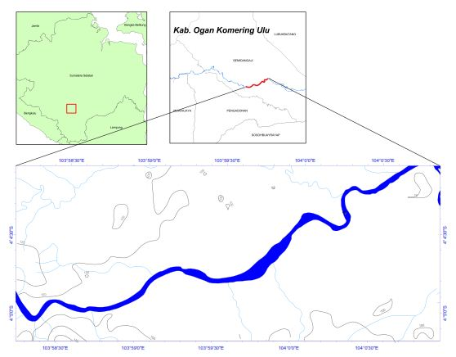
Figure 1. Location of study area

This research was carried out on a river body that has a meander by comparing changes in river morphometry parameters in 1990 and 2016. Composition lithology at the research site is dominated by sedimentary rocks in the form of alluvial deposits, where the rock is less resistant. So that it affects erosion on the banks of the river, especially on the banks of the river.

- Research Methods
The guided classification of maximum likelihood is one of the most commonly used in determining the type of land use. Training samples that had been determined for each type of land used, such as plantations and rice fields, residential land and vacant land, and water areas (rivers) by conducting direct surveys in the field using GPS (global positioning system). Maximum likelihood is algorithm which was related to pixel value to get the maximum similarity of a vector that had not been classified according to the class that had been determined in the training sample for each object of land use [3]. The following is a research method flowchart (Figure 2).

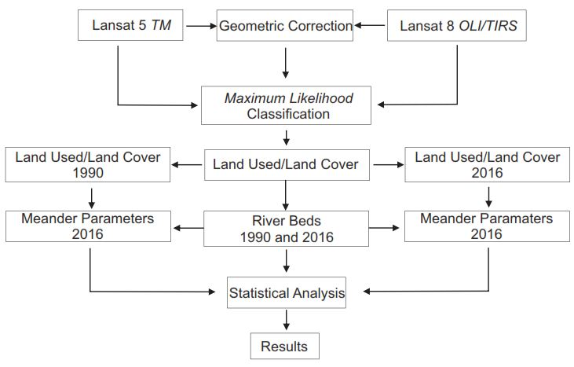
Figure 2. Chart of research flow

The river parameter meander used: river width (W), water flow length (S), meander neck length (L), axis length (A), radius of curvature (R) and sinuosity (C) calculated by equation (C = S / L) based on the meander parameter curve model [4]. In detail, the parameters of the river width are the lowest average distance from the river bank, the length of the water flow was the length of the river flow between two winding aspects, In detail, the parameters of the river width are the lowest average distance from the river bank, the length of the water flow was the length of the river flow between two winding aspects, the meander neck was the lowest distance of between two meander, radius of curvature is of the maximum interior circle in meander curve (Figure 3).

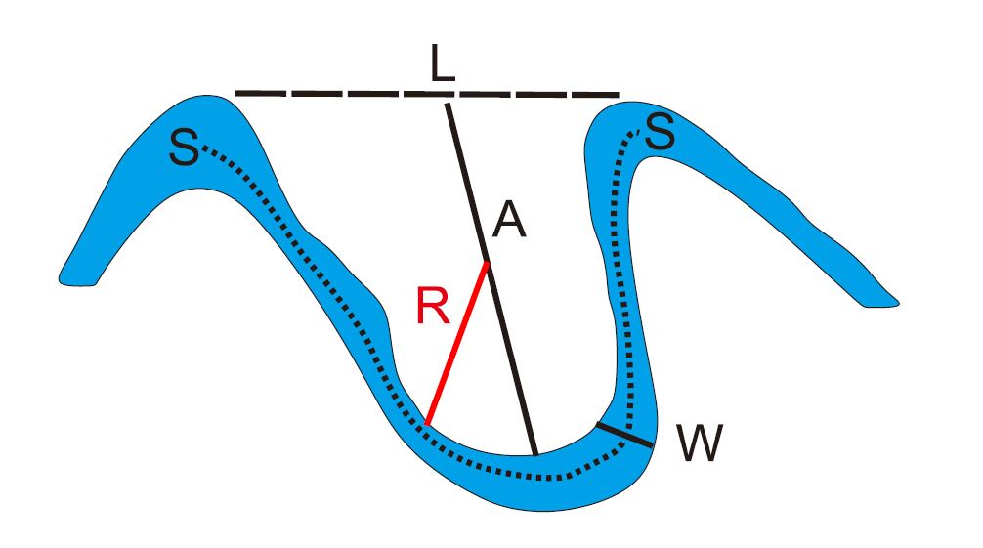
Figure 3. Model of curve winding morphometric parameters

To consider the meander morphometry parameters, the center lines of the research river channels in 1990 and 2016 were digitized into seven series of loop curves that identified changed based on meander curve changed model [5]. Furthermore, it was measured and calculated for each meander curve using a measuring device in Autocad 2013 (Figure 4).

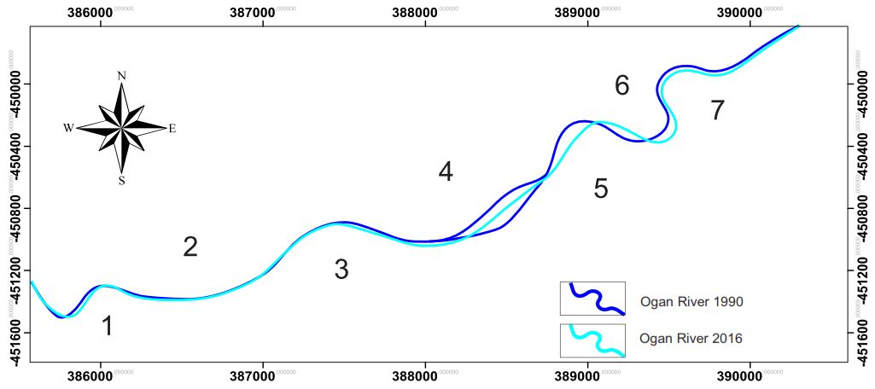
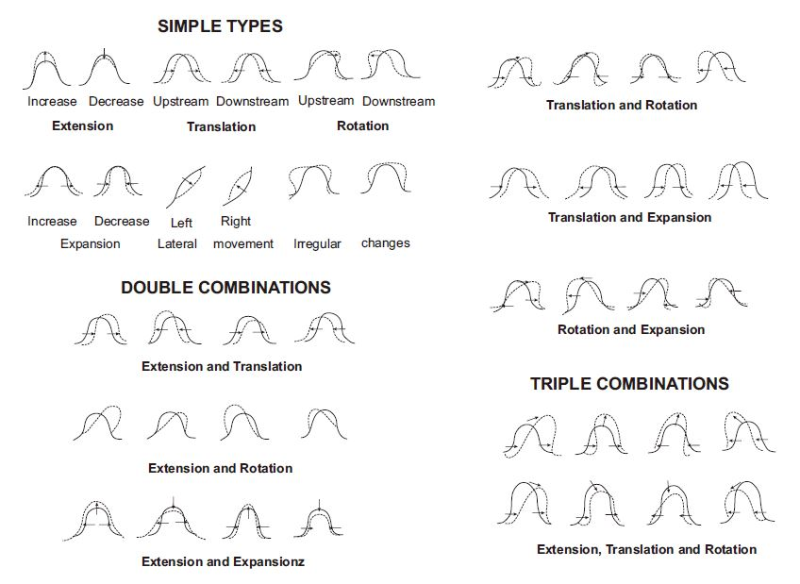
Figure 4. The center line of the river channel and meander curve change model

- Results and Discussion
- Map of Land Use.
Mapping of land used at the research site had been identified as five classes of land use consisting of areas (rivers), plantations, agriculture, shrubs, settlements and vacant land (attachments). The results of the study on land used maps have increased the area of land use for the vegetation area on mixed plantation land and rice fields. Whereas, in bush land, water areas (rivers), residential areas and vacant land have decreased (Figure 5).
Changes in plantation land use experienced a very significant increase in the location of the study, this was due to the surrounding community changing the function of the land, especially the bush area which had been converted into plantation land and rice fields to survive, because most of the surrounding communities were farmers.

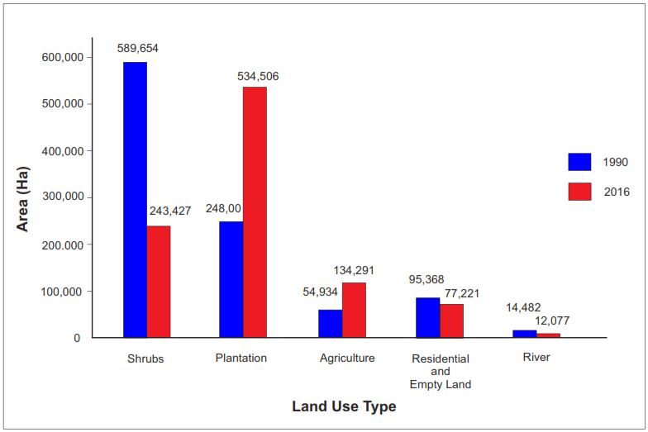
Figure 5. Development of the type of land use in the research location

- Changes in Meander Morphometry
Changes in morphology meander of the seven winding loops in the study show that there are two types of tortuous changes, namely types of simple and combination changes. On the tortuous curves (5, 6, and 7) are morphological changes with the type of combination namely extension and translation and extension and expansion in river flow in the study location (Figure 6).

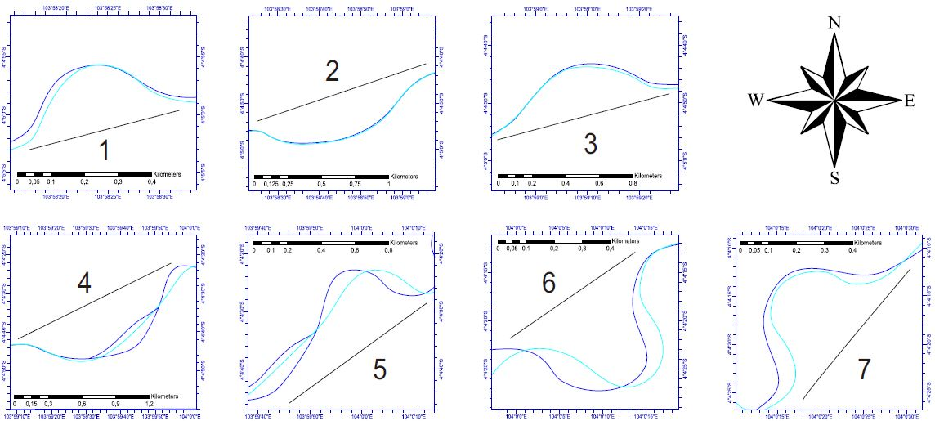
Figure 6. Seven center lines of the river channel at the research location

Based on the calculation results of each entanglement morphometric meander parameter, the average value of L (meander neck length) and S (length of water flow), and R (radius of curvature) have decreased. Conversely, W (river width), A (axis length) and C (sinuosity) have increased. For standard deviation (SD) meander neck length (L), axis length (A), radius of curvature (R), river width (W) and increase in sinuosity (C). Meanwhile, the length of water flow (S) in 1990 was higher than in 2016, which means a decrease (Table 1).

Table 1. Results of calculation of meander morphometric parameters
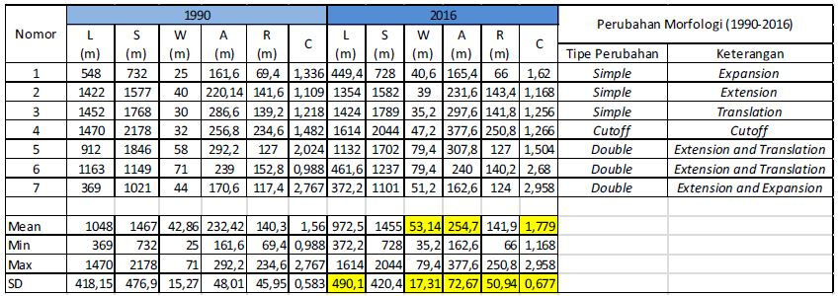

Based on the calculation above, the sinuosity index values ​​on the meander 5, 6 and 7 curves have been obtained representing changes that increase with the sinuosity values ​​of 1.504, 2.68 and 2.958 respectively. This, it can be said that the meander is growing or increasingly meander according to [6]. That rivers have meander evolution types obtained through the sinuosity index value. The sinuosity index value with a ratio <1.1 is a straight groove, a sinuosity index with a ratio of 1.1 - 1.5 is a sinuous, and the sinuosity index ratio> 1.5 is a meander (Figure 7).

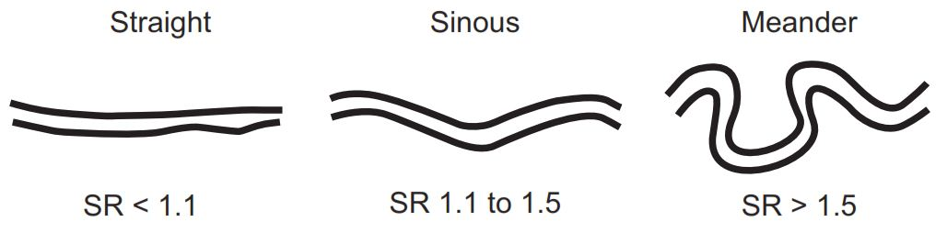
Figure 7. Evolution type meander based on sinuosity index value

- Paired T-test analysis
Analysis of the statistical tests of two paired samples was carried out on the same two meander morphometric parameter data in 1990 and 2016 using Microsoft Excel. Based on this paired T-test there is a significant change in the width of the river (W) with a confidence degree of 95%, while for the length between the neck meander (L), radius of curvature (R), water flow length (S), axis length A) and sinuosity (C) there were no significant differences (Table 2).

Table 2. Paired T-test results
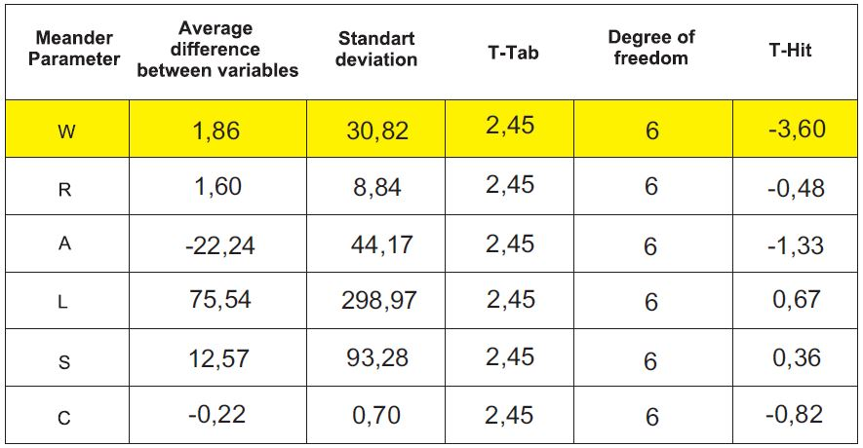

- Pearson Correlation Test
The Pearson correlation test was performed on both tortuous parameters in 1990 and 2016 using the SPSS 14 program. Based on the Pearson correlation test there is a significant relationship between radius of curvature (R) and water flow length (S), axis length (A) and meander neck length (L) and water flow length (S) with a confidence level of 95%. A significant relationship also lies in the river width (W) with the radius of curvature (R) and between the water flow length (S) and the axis length (A), which is obtained with a confidence level of 99%. Whereas, between sinuosity (C), river width (W), curvature radius (R), meander neck length (L), water flow length (S) and axis length (A) there is no significant relationship (Table 3).

Table 3. Pearson correlation test
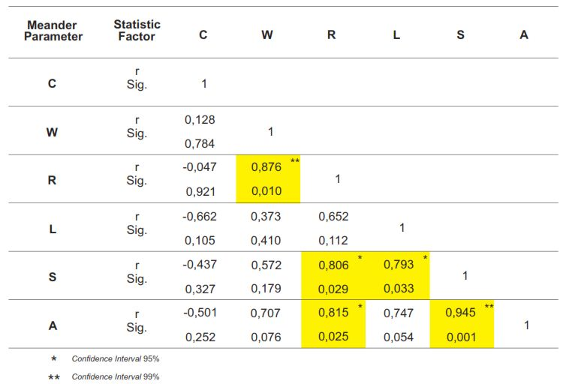

- Conclusion
Indirectly there has been degradation in the flow of morphology, especially in river meander. This affects the characteristics of meander morphometry parameters with increasing river width parameters which can cause erosion on the river bank. By maintaining the natural vegetation of a river system without changing the function of land on the river bank, it can control erosion and can evaluate the risk of flooding.

Acknowledgement
The author would like to thank Allah S.W.T. who have given lifelong blessings to date, so that the author can complete the research and creation of this journal. As well as the Parents who have ceaselessly provided support in the form of prayer and material.

References
[1] Hooke, J. M., 2013. “River Meandering,” in Treatise on Geomorphology., vol. 9. Shroder J. F, Ed. Academic Press San Diego, 2013, pp. 260-288.
[2] As-syakur A.R, Suarna I.W, Adnyana I.W.S, Rusna I.W, Laksmiwati I.A.A, Diara I.W. (2008). "Studi Perubahan Penggunaan Lahan di DAS Bandung". Jurnal Bumi Lestari, pp. 100-108.
[3] Jia K, Xiangqin W, Xingfa G, Yunjun Y, Xianhong X, Bin L. 1014. Land cover classification using Landsat 8 Operational Land Imager data in Beijing, China. Geocarto International. 19: 941-951.
[4] Yousefi, S., Poughasemi, H.R, Hooke, J., Navartil, O., Kidova, A., 2016. Changes in morphometric meander parameters identified on the Karoon River, Iran, using remote sensing data. Geomorphology. GEOMOR 5707.
[5] Hooke, J., 1984. Changes in river meanders – a review of techniques and results of analyses. Progress in Physica Geography 8, 473–508
[6] Charlton, R. 2008. Fundamentals of Fluvial Geomorphology. London and New York: Rouledge Taylor and Francis Group.
ATTACHMENT (LAMPIRAN)

