WATER AND LAND PRODUCTIVITY OF LETTUCE (Lactuca sativa)

AT FLOATING POT ON WETLAND

Lily Endah Diansari^{1,*}, Satyanto K. Saptomo², Budi Indra Setiawan³

¹Program Studi Teknik Sipil, Sekolah Tinggi Teknologi Pagar Alam

² Departemen Teknik Sipil dan Lingkungan, Institut Pertanian Bogor
³ Departemen Teknik Sipil dan Lingkungan, Institut Pertanian Bogor
*Corresponding Author: diansarilily@gmail.com

Abstract
The objective of this study was to determine the values of water productivity and land productivity at the floating pot on wetland and to find out whether the floating pots were optimal or not for agriculture in wetlands. The planting media used were mineral soil, and peat soil consisting of 0%, 30%, 50%, 70% and 100% each of which had hydraulic conductivity values respectively except the 100% was 36.07 cm/hour, 38.33 cm/hour, 51.23 cm/hour and 69.60 cm/hour. The water delivery used was legacy cloth which had hydraulic conductivity value was 158.4 cm/hour. The floating pots were applied to the experiment tank in the greenhouse. The decrease in water level in the experimental pool was total evapotranspiration for all plants in five types of planting media. Water level reduction during the 41-days planting period was 40.56 mm with a total water volume was 0.081 m³. The productivity values of land and water in the 0%, 30%, 50%, 70% and 100% peat planting media, respectively were 1.29, 1.25, 1.06, 0.8 dan 0 kg/m² dan 1.63, 1.63, 1.38, 1.04 dan 0 kg/m³.
Keywords: floating pot, water productivity, land productivity, sub-surface irrigation

Abstrak (Indonesian)
Penelitian ini bertujuan untuk mengetahui nilai produktivitas air dan lahan pot terapung di lahan basah dan untuk mengetahui apakah pot terapung tersebut optimal atau tidak untuk pertanian di lahan basah. Media tanam yang digunakan adalah tanah mineral dicampur tanah gambut 0%, 30%, 50%, 70%, dan 100% yang masing-masing mempunyai nilai konduktivitas hidrolik kecuali yang 100% adalah 36.07 cm/jam, 38.33 cm/jam, 51.23 cm/jam dan 69.60 cm/jam. Media penghantar air yang digunakan adalah kain legacy yang memiliki nilai konduktivitas hidrolik sebesar 158.4 cm/jam. Pot terapung kemudian diterapkan pada bak percobaan dalam rumah tanaman. Penurunan muka air selama 41 hari masa tanam adalah 40,56 mm dengan volume total airnya adalah 0.082 m³. Nilai produktivitas air dan lahan tanaman selada pada media tanam 0% gambut, 30% gambut, 50% gambut, 70% gambut dan 100% gambut masing-masing adalah 1.37, 1.63, 1.06, 1.57 dan 1.42 kg/m³ dan 1.29, 1.25, 1.06, 0.8 dan 0 kg/m².
Kata kunci: pot terapung, produktivitas lahan, produktivitas air, irigasi bawah permukaan

- Introduction
Wetlands are ecosystems that form, process and characterise controlled by water for an extended period for the development of vegetation and specially adapted organisms (Rieley et al. 1996). Indonesia is a country that has extensive peatland, which is an area of 18 million hectares (Najiyati et al. 2005) and 1 million hectares of which are in South Sumatra. Of the total peatland area in South Sumatra, only 0.37 hectares is cultivated for rice once a year, while around 119 thousand is quite potential for rice plants but has not been utilised (Waluyo and Supartowo 2014). In addition to low soil fertility, another obstacle to agriculture in wetlands was water management related to the excessive nature of water during the rainy season and drought during the dry season (Bakri et al. 2015).
At the event of flooded land, farmers usually leave their land inundated without planting even though a floating farming system could be applied to the flooded land. Bernas et al. (2012) planted kale on bamboo rafts with the treatment of planting media in the form of soil and mixing organic fertiliser from water hyacinth and water nails. Vegetable planting could be done several times in one flood season so that it could increase farmers' income.
The success of planting the water spinach, then planting other vegetables could be done with floating media specifically designed for wetlands. The irrigation system applied to float agriculture was subsurface irrigation. The subsurface irrigation system was carried out by giving water to plants by seeping water into the root area (Kang and Zhang 2004).
One application of floating farming was a floating pot designed so that it can float and seep water from the bottom to the roots of the plant. Because irrigation systems that was applied to floating pots where subsurface irrigation systems and on open wetlands, it was necessary to know the amount of water used by plants during growth to obtain water productivity results. The productivity of floating pots in wetlands also needed to be known to compare them with land productivity on conventional land. This study aimed to determine the productivity value of floating water and potted land in wetlands and to determine whether the floating pots are optimal or not for agriculture in wetlands.

- Experimental Section
  - Floating Pot
Floating pot material was Styrofoam which had a density value of 0.015 g / cm³. The subsurface irrigation floating pot irrigation system by seeping water from the bottom into the planting medium through the porous material. The type of porous material used provides an essential role in controlling the rate of irrigation water into the soil, especially in the characteristics of its hydraulic conductivity. Porous pot material was legacy fabric. The legacy fabric has a permeability value of 158.4 cm/hour. This value was higher than the planting media to be able to maintain water seepage from the subsurface to the planting media and maintain the moisture of the planting media. The dimensions of floating pots for vegetables in this study were 15 cm pot diameter and 17 cm pot height. Floating pot porous measuring 17 cm long, 13 cm outside the pot and 4 cm in the pot.
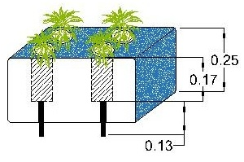

Figure 1. Floating Pot

  - Planting Media
This study uses five types of planting media, namely planting media with a composition of mineral soil mixtures and 0, 30, 50, 70 and 100% peat soil (G).

Table 1 The results of the analysis of the physical properties of soil samples
Parameters |  | Type of soil
 |  | 0% G | 30% G | 50% G | 70% G
Bulk Density (g/cc) |  | 0.66 | 0.66 | 0.61 | 0.59
Particle Density (g/cc) |  | 1.3 | 1.54 | 1.50 | 1.26
Soil porosity (% volume) |  | 57% | 53% | 57% | 59%
Saturated soil hydraulic conductivity (cm/hour) |  | 36.07 | 38.33 | 51.23 | 69.60
Water content (%volume) | pF1 | 52.00 | 41.10 | 40.70 | 36.80
 | pF2 | 44.60 | 39.40 | 37.70 | 31.10
 | pF2.54 | 40.50 | 34.00 | 32.00 | 27.80
 | Pf4.2 | 35.40 | 26.80 | 23.70 | 20.70

  - Evapotranspiration
The amount of water consumed by plants in floating pots on wetlands was known by calculating the value of evapotranspiration. The reference evapotranspiration value was calculated based on climatology data at the research location and the Dramaga Climatology Station belonging to the Meteorology, Climatology and Geophysics Agency (BMKG). Calculation of reference evapotranspiration following the FAO Penman-Monteith modification equation with the equation according to Allen (1998) was:

$${ET}_{0}=\frac{0,408∆\left(Rn-G\right)+γ\left(\frac{900}{T*273}\right)U_{2}(es-ea)}{∆+γ(1+0,34 U_{2})}$$ | (1)
ET₀ was a reference evapotranspiration (mm day-1), Rn was net radiation on the plant surface (MJ m⁻² days⁻¹), G was the daily soil material flux density (≈ 0 MJ m⁻² days⁻¹), U was average the speed of wind at the height of two meters (m seconds-1), Es was a saturated vapour pressure (kPa), Ea was the actual vapour pressure (kPa), Δ was the slope of the vapour pressure curve (kPa of-1), γ was a psychometric constant (≈ 0.0667 kPa ºf-1), and T was the average air temperature (ºC).

  - Land and Water Productivity of Lettuce
Water consumption by plants in each planting medium was known by measuring the volume of water used by plants during growth. Water productivity of lettuce plants was formulated as follows:

$$Water Productivity=\frac{Lettuce production (Kg)}{Water volume of ETc (m^{3})}$$ | (2)

- Results and Discussion
  - Decreasing Water Level and Water Consumption Rate
The decrease in the pond water level of floating farming systems and the rate of evapotranspiration was presented in Figure 3. The average water level reduction was 0.989 mm / day with 41 days total water loss of 40.56 mm or equal to 0.081 m³ for a pool area of 2 m and width 1 m. Water level reduction was total evapotranspiration for all plants in five types of planting media. During the cultivation period, the water level from the surface of the pond continues to decline.
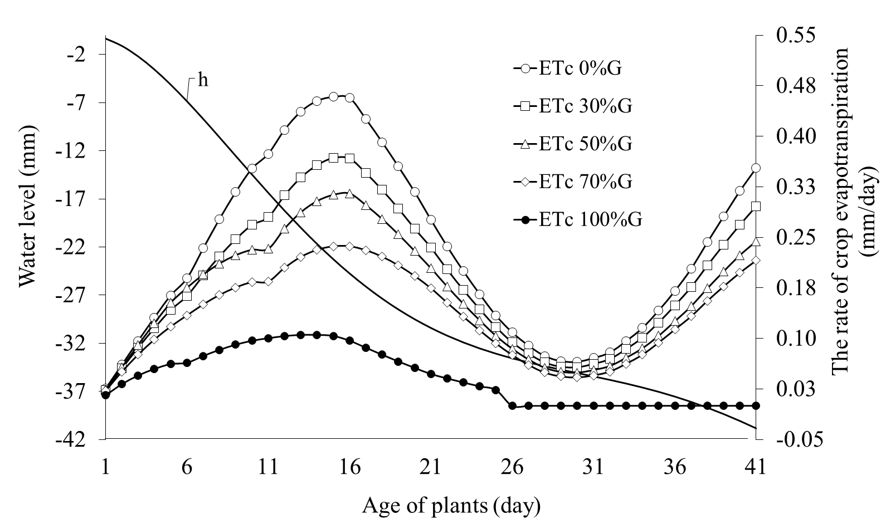

Figure 2. The graph of the relationship between water level reduction and evapotranspiration rate

The decrease in water level was interpolated using the 5th order polynomial equation. The equation was formed based on the measurement of water level reduction data based on CTD sensor measurements which tend to connect the trendline points. The 5th order polynomial equation was in the form of:
h = a t⁵ – b t⁴ + c t³ –d t² – e t - f; (4)
a = 2.04487 x 10⁻⁰⁶, b = 0.00028297, c = 0.01353, d = 0.24143, e = 0.12326, f = 0.00028, h was the water level measured by the sensor (mm) and t was the time (day). This 5-order polynomial equation was good enough to present a form of a tendency to decrease the water level based on CTD sensor measurements. This was based on the correlation value (R²) obtained at 0.997.
The negation of the derivative of order 5 of the polynomial equation was the rate of evapotranspiration of plants. The total value of the plant coefficient (Kc) was obtained from known plant evapotranspiration values and reference evapotranspiration. The rate of crop evapotranspiration in each planting media was the result of the decomposition of the total plant evapotranspiration rate. Decomposition of total Kc values into Kc units was optimized using the program solver in Microsoft Excel. Kc value analysis uses the function of plant height and volumetric water content on the growing media every day so that the value of Kc obtained was different in each planting medium and every day. The total water consumption of plants after being analyzed during growth in the growing media of 0% G, 30% G, 50% G, 70% G and 100% G was 9.41 mm, 7.76 mm, 6.82 mm, 5.60 mm and 1.69 mm.
Figure 2 was also a scheme of the rate of evapotranspiration in lettuce plants in floating farming systems. The annual evapotranspiration value of plants depended on the age of the plant every day. The evapotranspiration value of plants was still small and continues to increase in the early vegetative phase then decreases until the middle vegetative phase. Entering the final vegetative phase, evapotranspiration increased again until the final phase and was ready for harvest. At the beginning of plant growth, evaporation reaches its maximum because the surface of the planting medium has not been covered by plant canopy. Evaporation would decrease in line with plant growth (Hermantoro and Pusposutarjo 2000). When plants enter the final vegetative phase, plants needed more water than the initial vegetative phase, so that evapotranspiration increases again until the plants were ready to be harvested.

  - Lettuce Plant Production
The results of the fresh and dry weight of lettuce production in each planting medium vary as presented in Table 2. The 0% G planting media has the highest production tendency because the planting media without a mixture of peat soil can maintain greater water for plant needs.

Table 2: Production of lettuce plants
Types of planting media | Fresh stovers weight (grams) | Dry stovers weight (grams) | Fresh root weight (grams) | Dry roots weight (grams)
0% G | 22.73 | 1.13 | 4.45 | 0.35
30% G | 22.17 | 1.11 | 3.82 | 0.22
50% G | 18.91 | 0.96 | 3.53 | 0.19
70% G | 14.03 | 0.75 | 3.24 | 0.16

  - Water and Land Productivity of Lettuce Plants
Based on the production of lettuce plants cultivated in floating pots in greenhouse by applying subsurface irrigation, the productivity of water and plant land was obtained from the ratio of wet weight in each planting medium. The total consumption of plant water during growth in the planting medium 0% G, 30% G, 50% G, 70% G and 100% G are 9.41, 7.76, 6.82, 5.60 and 1.69 mm. The results of the calculation of lettuce crop productivity are presented in Figure 5. Water productivity of plants in planting media 0%, 30%, 50% and 70% of peat respectively are 1.37, 1.62, 1.57 and 1.42 kg / m³. The planting media of 100% peat does not produce lettuce, so the water productivity was 0 kg / m³. The productivity of lettuce in this study was greater than the productivity of drip wet irrigation water with limited water supply (Contreas et al. 2008) with a value of 0.61 kg / m³.
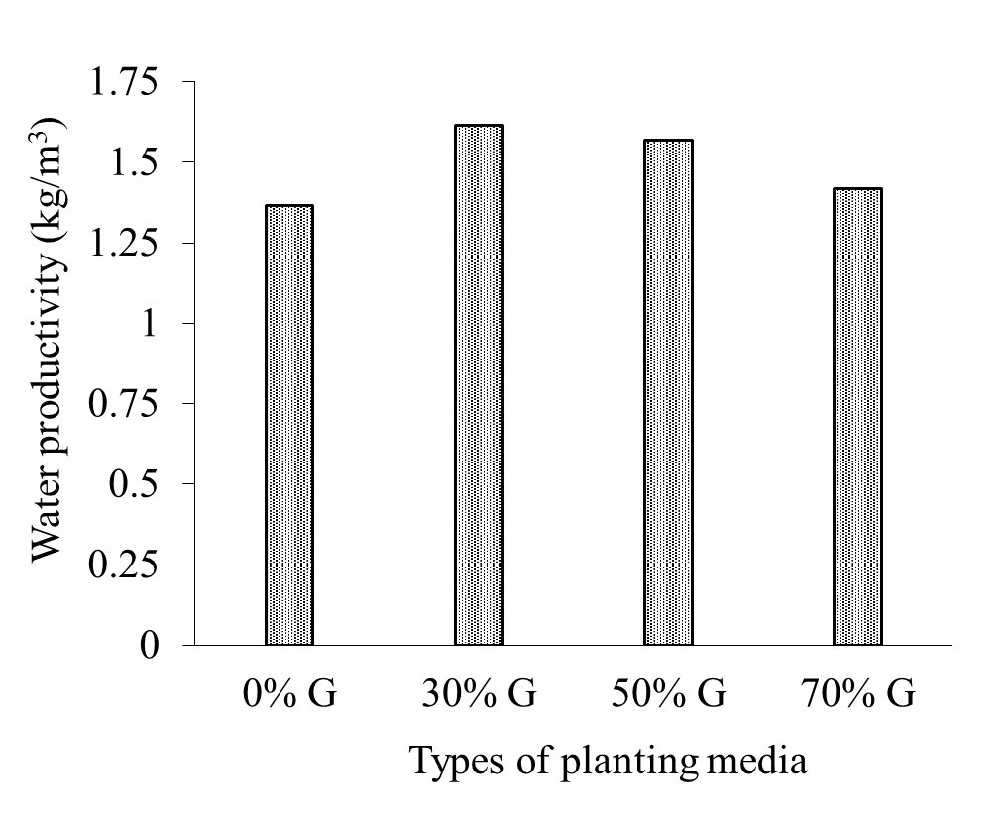

Figure 3. Water Productivity Productivity of Lettuce Plants

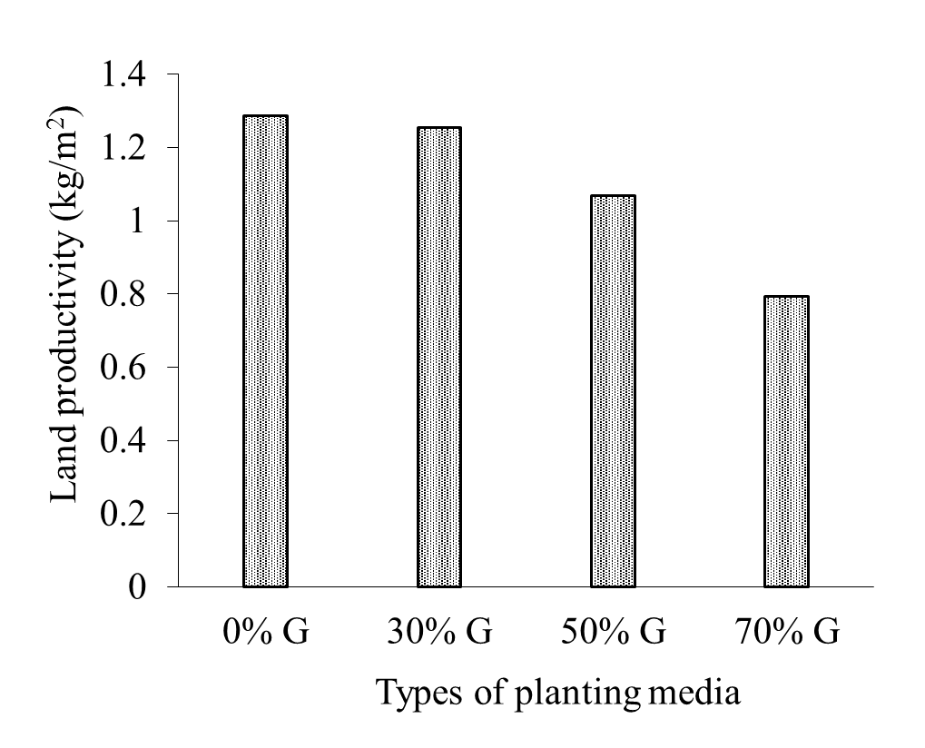

Figure 4. Land Productivity of Lettuce Plants

The results of calculation of lettuce crop productivity are presented in Figure 4. Productivity of plant land in planting media 0%, 30%, 50% and 70% of peat respectively are 1.29, 1.25, 1.06 and 0.8 kg / m². The land productivity in this study was greater with the productivity of lettuce plants in the hydroponic system carried out by Prawoto and Kartika (2016), which amounted to 1.27 kg / m².

- Conclusion
Floating pots were applied to the experiment tank at the greenhouse with five types of planting media, namely mineral soil with a mixture of 0% peat, 30% peat, 50% peat, 70% peat and 100% peat. Water level decreased during the 41 day planting period was 40.56 mm with a total water volume of 0.081 m³. The water productivity value of lettuce plants in the planting media of 0% - 100% peat respectively were 1.37, 1.62, 1.57, 1.42 and 0 kg / m³. The value of land productivity of lettuce in the planting media of 0% - 100% peat was 1.29, 1.25, 1.06, 0.8 and 0 kg / m², respectively. Planting lettuce on floating pots could be applied to optimize wetlands for agriculture because the value of productivity of water and land could be greater than conventional planting of lettuce plants.

References
R.G. Allen, L.S. Pereira, D. Raes, M. Smith. Crop Evapotranspiration - Guidelines for Computing Crop Water Requirements. Rome (IT): Food and Agriculture Organization of the United Nations (FAO). 1998.
B. Bakri, M.S. Imanudin and S.M. Bernas. “Water Retention Option of Drainage System for Dry Season Corn Cultivation at Tidal Lowland Area.” Agrivita, vol 37, issue 3, pp 237, 2015.
S.M. Bernas, A. Pohan, S.N.A. Fitri and E. “Kurniawan.. Model Pertanian Terapung dari Bambu untuk Budidaya Kangkung Darat (Ipomoea reptans Poir.) di Lahan Rawa.” Jurnal Lahan Suboptimal, vol 1, pp 178-185, 2012.
S. Contreras, A.B. Mark and T. David. “Restricted Water Availability During Lettuce Seed Production Decreases Seed Yield per Plant but Increases Seed Size and Water Productivity.” Hort Science, vol 43, issue 3, pp 837-844, 2008.
Hermantoro and Pusposutarjo. “Pemodelan Pertumbuhan dan Pemakaian Air Tanaman Palawija di Lahan Kering.” Buletin Keteknikan Pertanian, vol 14, issue 2, pp 139-149, 2000.
Kang S. and Zhang J. “Controlled alternate partial root-zone irrigation: its physiological consequences and impact on water use efficiency.” Journal of experimental botany, vol 55, issue 407, pp 2437-2446, 2004.
S. Najiyati, L. Muslihat and I.N.N. Suryadiputra. “Panduan Pengelolaan Lahan Gambut untuk Pertanian Berkelanjutan. Proyek Climate Change, Forests and Peatlands in Indonesia.” Bogor: Wetlands International - Indonesia Progamme. 2005.
R.P. Prawoto and J.G. Kartika. “Pengelolaan Aspek Produksi dan Pasca Panen Sayuran Daun Secara Aeroponik dan Hidroponik: Studi Kasus Lembang, Bandung”. Bul. Agrohorti, vol 4, issue 1, pp 9-19, 2016.
J.O. Rieley, A.A. Ahmad-Shah and M.A. Brady. “The Extern and Nature of Tropical Peat Swamps” in Maltby E et al., editor. Proc. Of a Workshop on Integrated Planning and Management of Tropical Lowland Peatlands, IUCN, pp 17-54, 1996.
Waluyo and Supartowo. “Peluang dan Kendala Pengembangan Pertanian pada Agroekosistem Rawa Lebak: Kasus Desa Kota Daro II di Kecamatan Rantau Panjang Kabupaten Ogan Ilir Sumatera Selatan.” in Proc. Prosiding Seminar Nasional Lahan Suboptimal, 2014, pp 704-713.

