Analysis of Domestic Wastewater Management Systems in Low Income Residential Areas

Dody Eko Prasetyo¹, Heni Fitriani¹, dan Betty Susanti¹

¹Faculty of Engineering, Civil Engineering Department, University of Sriwijaya, Palembang Region, Indonesia.

*Corresponding author email: dody_ep@yahoo.com

Abstract
Statistically, access to proper sanitation in Muara Enim Regency reaches 90.75% in 2018, but it needs to be ascertained whether it is safe in the context of no latrine leak that can pollute the environment, especially in areas with the lowest level of population welfare. Muara Lawai village is the village that has the highest number of poor and near poor people and villages with status as underdevelop village in Muara Enim District. Based on an analysis of existing conditions, the facilities for wastewater sanitation infrastructure used by low-income communities (MBR) and non-MBR in Muara Lawai Village were found to be still not feasible and safe. Efforts to provide adequate and safe sanitation infrastructure that can be implemented in Muara Lawai Village are a off-site domestic settlement wastewater system with initial service coverage for 41 households or 205 people. total wastewater generation (Q_{r}) 16.40 m³ / day with peak discharge (Q_{peak}) of 54.82 m³ / day, minimum discharge (Q _{min}) 2.33 m³ / day and infiltration discharge (Q_{inf}) 12.96 m³ / day, so the design discharge is obtained at 67.78 m³ / day. Calculation results in the service sub-system required a special PVC waste pipe with a roughness value (manning) of 0.012 with details of house connections pipe size 4"along 212.1 m, service pipe size 6" along 178.8 m and main pipe size 8"along 220.7 m. The need for control tubs is 31 units installed at each pipe meeting with a size of 50 x 50 x 50 cm. In the processing sub-system (WWTP building), the processing technology used is anaerobic biofilter with the overall dimensions of the WWTP building of 7.5 x 2.0 x 2.5 m.
Keywords: Low Income Communities; Domestic Wastewater Treatment System

1. Introduction
Sanitation (Ministry of Public Works, 2014) is an effort to guarantee and improve environmental sanity in a residential area, including collection, treatment and disposal of wastewater, waste and drainage. Unhealthy sanitation in humans can causes iron deficiency, cognitive developmental disorders and stunting in children (M. L. McKenna et al., 2017). Waste management problems that often occur in low and middle-income countries are caused by a lack of skilled local technicians, institutional capacity, and finance (C. Cossio, J. Norrman, J. McConville, A. Mercado, and S. Rauch, 2020). The typical low sanitation in South Sumatra Province is dominated by the characteristics of people with low welfare who live in densely populated areas and with unclean and unhealthy living habits which become their culture (Central Bureau of Statistics Muara Enim, 2018). However, the community is very eager to change their sanitation infrastructure to be healthy and decent, but is constrained by knowledge and inability to finance it (National Team for the Acceleration of Poverty Reduction (TNP2K), 2018).
Statistically, the indicator of sanitation feasibility is measured by the percentage of households that have access to adequate sanitation, namely access to wastewater management in the form of healthy latrines using goose neck closet and feces disposal sites using septic tanks or domestic wastewater treatment systems. Access to proper sanitation in Muara Enim District has been very good, reaching 90.75% in 2018(Central Bureau of Statistics Muara Enim, 2018). From around 578,897 population of Muara Enim Regency, there are still around 53,547 people or 9.25% who do not yet have access to proper sanitation (Central Bureau of Statistics Muara Enim, 2018).
Muara Enim District as the capital of Muara Enim Regency has the highest population and population density out of the 20 Districts in Muara Enim Regency (Central Bureau of Statistics Muara Enim, 2018). Muara Lawai Village in Muara Enim Subdistrict is the village with the highest number of Poor and Near Poor Families in Muara Enim District which is 72.48% (National Team for the Acceleration of Poverty Reduction (TNP2K), 2018). A healthy lifestyle with regard to environmental sanitation needs important attention, especially for densely populated areas with low economic levels (S. Ichwan Prastowo, 2016). The results explained that communal wastewater treatment plants in densely populated areas with low economic levels can improve living standards. A study (A. Ristiawan, P. Purwono, and A. U. Ulya, 2019) in a densely populated residential area and located on the banks of a river, found that about 93% of households already have a walking closet (WC) and 83% already have a septic tank. But the problem is that the septic tank is never sucked up. The communal wastewater treatment plant (WWTP) planning program is offered to the community and around 72% of households approve the communal WWTP program.
This is interesting to study considering that although the achievement of sanitation access has been good, it is also necessary to ascertain whether the high achievement is followed by safe sanitation in the context of not experiencing leakage which can pollute the environment, especially in the densely populated areas with low welfare levels. For this reason, a study is needed in analyzing the existing conditions of sanitation, which then analyzes the technology selection and provision of domestic wastewater treatment system that is suitable for the typical conditions above, namely in the Muara Lawai Village, Muara Enim District. The scope of wastewater sanitation and wastewater infrastructure reviewed in this study are domestic household wastewater in the form of sewage water (black water).

2. Experimental Section
2.1 Literatur Review
Domestic wastewater comes from residential activities, houses, apartments, offices, businesses and so on with an average flow of wastewater varies according to the designation and region(Minister For Public Works and Human Settlements, 2017). According to (G. Tchobanoglous, F. L. Burton, and H. D. Stensel, 2003), domestic wastewater flow is categorized in residential areas, institutional areas, commercial areas and recreation areas. Domestic wastewater treatment system is a series of domestic wastewater management activities in a single unit with domestic wastewater management infrastructure and facilities.
Domestic wastewater treatment system is divided into two management systems, namely Local / On-site and Centralized / Off-site. Off-site domestic wastewater treatment system is a management system that is carried out by draining domestic wastewater from sources collectively to a centralized treatment sub-system to be treated before it is discharged into water bodies (Minister For Public Works and Human Settlements, 2017). Off-site domestic wastewater treatment system is divided into settlement scale, specific area scale and urban scale. This system has complete services including wastewater treatment plan (WWTP), primary pipe, secondary pipe, tertiary pipe, pumping station (depending on needs) and relative range over a wide area. In selecting options between the on-site or off-site domestic wastewater treatment system, 5 factors (Minister For Public Works and Human Settlements, 2017) as listed in Table. 1 should be considered.

Table 1. Domestic Wastewater Treatment System Type Selection Factors
No | Parameter | Criteria
 |  | On-Site | Off-Site
1 | Population Density | <150 People/ha | >150 People/ha
2 | Groundwater Level Depth | > 2 meters | < 2 meters
3 | Soil Permeability | < 5x10⁻⁴ | > 5x10⁻⁴
4 | Financing Ability | Capable | Capable
5 | Land Slope | 0 % or flat | <2% Settlement Scale,  >2% Urban Scale

The amount of wastewater in residential areas is generated from 60-80% of the use of clean water. In planning the amount of water generation, it is need to calculate the design discharge (Q_{design}) which is the sum of the peak discharge (Q_{peak}) and infiltration discharge (Q_{Inf}), with the equation as follows:
Q_{r} = (range 60 – 80%) x Volume of drinking water consumption x p (1)
Q_{min} = (1/5 x (p/1000)^{0,2} x Q_{r} (2)
Q_{peak} = Q_{r} x peak factor (3)
Q_{Inf} = $\frac{Area \left(ha\right) x peak factor (\frac{m3}{ha}.day)}{86400}$ (4)
Q_{design} = Q peak + Q Infiltration (5)

Information,
Q_{r} = amount of wastewater (m³/day)
p = total population (people)
Q_{min} = Minimum wastewater discharge (m³/day)
Q_{peak} = Peak wastewater discharge (m³/day)
Q_{inf} = Infiltration discharge of groundwater and rainwater
(m³/day)
Q_{design} = Design wastewater discharge
(m³/day)

Calculation of peak wastewater discharge and infiltration discharge need to be multiplied by the peak factor that refers to Figure 1 and Figure 2.
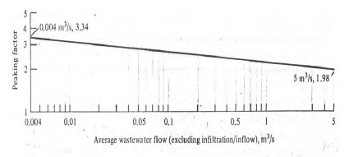
Figure 1. Peaking Factor for Domestic Wastewater Flows

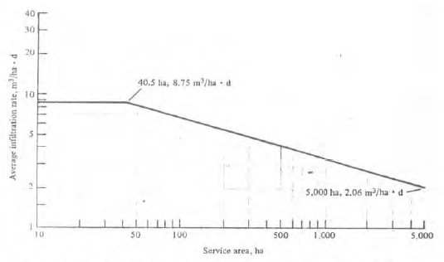
Figure 2. Average Infiltration Rate Allowance For New Sewer

Wastewater flow in the piping system is attempted using the gravity flow method for consideration of efficiency by engineered the pipe slope. Pipes must be designed in a half-full condition considering the required air space and anticipation if a maximum discharge occurs. For partial / half-full flow, the flow rate of wastewater must be in the range of 0.6 m / sec - 3 m / sec with an assumption of d / D 0.6-0.8. In addition, the use of piping materials will also affect the velocity of flow through roughness values (n).
According to the Detailed Engineering Planning Guidelines (Ministry of Public Works, 2018) there are several stages in planning a piping network system referring to the Planning Guidelines, as follows:
- Determining the value of the ratio d / D, (between 0.6 - 0.8). The value of d / D is the difference between the wet height and the diameter of the pipe used.
- Determine the values of Q_{p} / Q_{f} and V_{p} / V_{f}, by using the graphical reading of the hydraulic elements (figure 3) which refers to the value of d / D. Q_{p} is a discharge of partial flow and Q_{f} is a discharge of full flow.

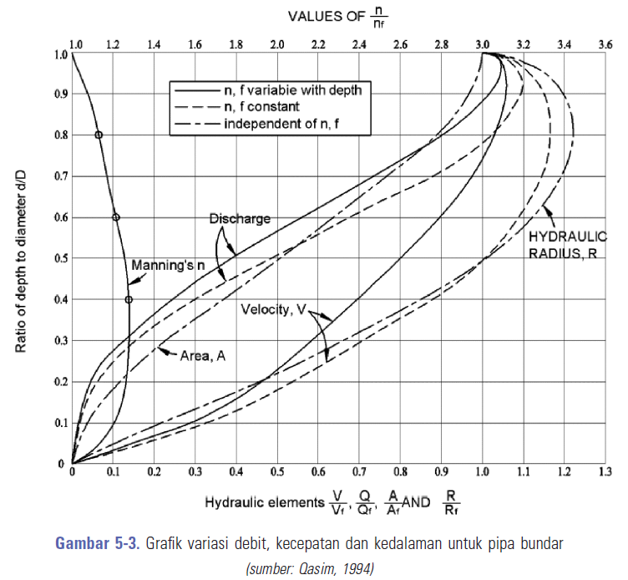
Figure 3. Hydraulic Element Graph

- Determine the roughness value (n) of the pipe, based on the type of pipe material used
- Determine the slope of the channel, with the equation:
S = (h1-ho)/L (6)
S_{minimum} = 0,01 x Q_{d} 0,667 (7)

Information,
S = Land Slope
h₀ = Initial pipe elevation
h₁ = End pipe elevation
S_{minimum}= Minimum slope
Q_{d} = Design discharge
- Calculate the pipe dimensions needed to be used with the equation:
d = $\left(\frac{Qfull x n}{0,3118 x S^0.5}\right)$^{3/8} (8)
Check,
V_{f} = $\left(\frac{{\left(\frac{D}{4}\right)}^{0,67}x S^{0.5}}{n}\right)$ (9)
V_{p} = V_{p}/V_{f} x V_{f} (10)

Information,
d = Pipe dimension needed
S = Slope
n = roughness coefficient
V_{f} = Full flow speed
V_{p} = Partial flow speed

In the piping system needed a control tub that functions as a control of sewerage. Control tubs are placed at each change in diameter, slope, and pipe assembly. On a straight control tubs are placed every 50-70 meters. WWTP buildings at settlement scale generally use anaerobic processing with efficiency considerations. The processing component consists of two tanks, namely an initial settling tank and an aerobic filter tub. Each tank is expected to reduce the hazardous substances that are processed in accordance with environmental quality standards, namely BOD 30 mg / L, COD 100 mg / L and TSS 30 ml / L (Ministry of Environment and Forestry Regulations Number 68 Year 2016).

Calculation of WWTP building needs through four stages as follows:
(1) Calculation of organic reduction, to determine the percentage of removal and COD / BOD / TSS out levels, with the equation,
(2) Calculation of the volume of sludge, to determine the cubically of the amount of sludge produced,
(3) Calculation of the volume of the tub to determine the cubically of the tub against the sludge produced,
(4) Calculation of tub dimensions to determine the appropriate tub dimensions based on the percentage of organic removal, sludge volume and volume of tubs, with the equation.

Table 2. WWTP Building Planning Criteria
I. Sedimentation Tub Design Criteria
- Retention time in the settling room,
T_{d} = 2 – 5 hours.
- Depth of settling, H = 1,5 – 4 m
- Surface Load, SLR = 30 – 50 m³/m².day
- BOD removal efficiency = 25%
II. Design Criteria for Aerobic Filter Tub
- Retention time in the settling room,
T_{d} = 6–8 jam.
- Up-Flow Velocity (V up) ≤ 2 m /hour
- Organic Load < 4 kg COD/m³.day
- BOD removal efficiency BOD 70–90%
- High Bed Microbial Breeding Media 0,9 – 1,5 m
- High Water Above Media Bed 20 cm
- The surface area of the media filter media volume unity = 90 – 300 m²/m³ media
Check,
T_{d} = (Vol l x w x h / Q ) x 24 hours (11)
Source : Detailed Engineering Planning Guidelines SPALD-T Cipta Karya, 2018

2.2 Methods
This study was conducted in the Muara Lawai Village which is the village with the highest number of poor and near poor people out of the 16 Villages in the District of Muara Enim and still included in the category of underdeveloped Villages (Ministry of Villages Development of Underdeveloped Villages and Transmigration of the Republic of Indonesia, 2018). Geographically, the residential areas in the Muara Lawai village are centered on the river banks which is susceptive to pollute the river. Figure 4 shows the distribution of settlements in Muara Lawai Village which is centralized in one location, which is the river bank

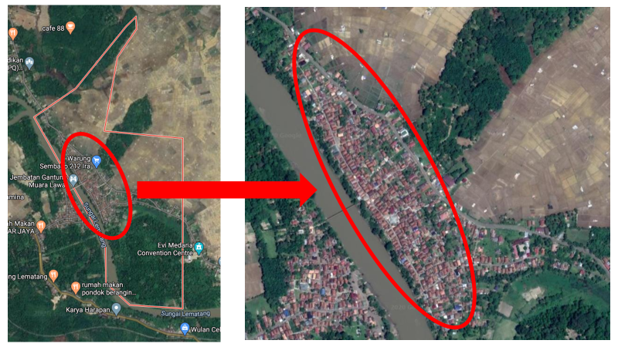

Figure 4. Distribution of Settlements in Muara Lawai Village

The data needed for this study is divided into primary data and secondary data. Primary data is the existing condition data obtained from the questionnaire, by counting the number of samples based on the number of people in Muara Lawai Village with 2,823 people or 436 households Central Bureau of Statistics Muara Enim, 2018)

Table 3. Total Population of Muara Lawai Village
Village | Total Population |  | Population Welfare Status  40% Lowest Group
 | Number of People | Number of Household | Number of People | Number of Household
Dusun I | 1,036 | 156 | 444 | 116
Dusun II | 813 | 126 | 348 | 91
Dusun III | 974 | 150 | 417 | 109
Total | 2,823 | 436 | 1.210 | 316

The sampling method was used a random sampling method that is done randomly without regard to the existing status in the population. The number of sample questionnaires using the Slovin formula with a 90% confidence level and a sampling error of 10%, so the formula used is:
n = $\frac{436}{1+436 \left(0,1\right)²}$
= 81,34 = 81 Households
Based on calculations, the total sample taken is 81 households in areas with high population density with considered the conditions in the area.

Table 4. Research Variable
No | Aspect | Variable
A | Existing Condition Analysis Variables
1 | Residential Building Data | Building Type
 |  | Number of Building Users
 |  | Building Status
 |  | Number of Latrines
 |  | Number of Septic Tank
 |  | Drinking Water Source
 |  | Electrical connection
2 | Accessibility | Home Access Road Conditions
 |  | Vehicle Parking Distance to the Septic Tank Hole
3 | Septic Tank Conditions | Septic Tank Position
 |  | Time of Construction
 |  | Last Suction Time
 |  | Septic Tank Type
 |  | Septic Tank Material
 |  | Septic Tank Base
 |  | Air Pipe / Ventilation
 |  | Suction Hole
4 | Financial | Total Household Income Per Month
 |  | Ability / Willingness to Build a Septic Tank
B | Domestic Wastewater Treatment System Development Planning Analysis
5 | Domestic Wastewater Treatment System Type Selection | Population density
 |  | Groundwater Surface Depth
 |  | Land Slope
 |  | Soil Permeability
 |  | Financing Ability
6 | Technical Calculation | Amount of Wastewater (Debit)
 |  | Hydrolysis radius
 |  | Waste Flow Speed
 |  | Wastewater Delay Time

The stages in this study include data collection (primary data through questionnaire surveys, secondary data through the results of literature studies), as well as data recapitulation and analysis. The questionnaire was prepared based on variables processed from various references, previous research studies, forum group discussion (FGD) and applicable regulations which were then grouped into two groups, namely the existing condition analysis variable which would describe the existing conditions of the research area and the planning analysis variables that would be used for domestic wastewater treatment system development planning in the study area (see Table 5).

3. RESULTS AND DISCUSSIONS
3.1 Existing Condition

In residential buildings aspect, there are 100% of respondents who privately owned residential building with an average number of lives per building 4.7 people, the average number of latrines and the number of septic tanks is 1 unit per household, 32.10% accessing drinking water from other source which is in this case is from river, 72.84% use electricity connection of 450 watts. Electricity connection is one of the benchmarks for the level of community welfare which indicates that population in Muara Lawai Village is dominated by household with a low welfare level or MBR.
In the accessibility aspect, there were only 39.51% of respondents who had a house to be accessed by large vehicles / trucks and had a safe parking space for desludging into household septic tanks with a distance of less than 10 m
In the aspect of septic tanks, that 88,89% of respondents do not know when the exact time of construction of a septic tank. As many as 100% have placed their septic tanks outside the house building with 88.89% non-fabricated septic tank types consisting of 58.33% made of concrete material and 41.67% made of masonry. As many as 96.30% of septic tanks have air holes and suction holes, but 100% of respondents stated that since they were built, they have never carried out a septic tank until now. This indicates that the lack of maintenance by the community could even make it possible for existing septic tanks to be built or built not to meet the standards and can pollute the soil and ground water considering the results of 88.89% of respondents stated that the built-in septic tank was not impermeable
In the aspect of financial condition, there are 27.16% of non-low-income communities (Non-MBR) and 72.84% of low-income communities (MBR) categories of 20.90% earning < IDR 1 million and 51.85% between IDR 1-2 million. However, 75.30% of the community stated that they have the ability to build septic tanks. So that the respondents have the ability and desire to have a proper and safe septic latrine.
With all the above conditions described in the Table 6, it can be concluded that the existing condition of the wastewater sanitation infrastructure are not feasible and safe yet, given the condition of the septic tank which is not impermeable and has never been treated with routine suction and scheduled due to septic tank conditions that do not meet standards.

Table 5. Recapitulation of Existing Wastewater Sanitation Conditions
No | Aspect | Variable | Eksisitng Condition
1 | Residential Building Data | Building Type | 100% private residence
 |  | Number of Building Users | average 4,7 people/household
 |  | Building Status | 100% privately owned
 |  | Number of Latrines | 100% have 1 unit/household
 |  | Number of Septic Tank | 100% have a septic tank with 1 unit / household
 |  | Drinking Water Source | 32,10% from river
 |  | Electrical connection | 72,84% use 450 watt
2 | Accessibility | Home Access Road Conditions | 39,51% accessed by large vehicles
 |  | Vehicle Parking Distance to the Septic Tank Hole | 27,16% > 30 meter
3 | Septic Tank Conditions | Septic Tank Position | 100% outside building
 |  | Time of Construction | 88,89% do not know
 |  | Last Suction Time | 100% never carried out
 |  | Septic Tank Type | 88,89% non-fabricated septic tank
 |  | Septic Tank Material | 41,67% made of masonry
 |  | Septic Tank Base | 88,89% not impermeable
 |  | Air Pipe / Ventilation | 3,70% no air holes
 |  | Suction Hole | 5,15% no suction hole
4 | Financial | Total Household Income Per Month | 72,84% under 2 million rupiah
 |  | Ability / Willingness to Build a Septic Tank | 75,30% ability to build

3.2 Selection of Domestic Wastewater Treatment Systems

According to (Minister For Public Works and Human Settlements, 2017), there are several criteria in the selection of the type of on-site domestic wastewater treatment system or off-site domestic wastewater treatment system by considering various factors.

Table 6. Comparison of Existing Conditions to The Selection Criteria For Sanitation Type
No | Paramater | Criteria |  | Existing | Choice
 |  | On-Site | Off-Site
1 | Population density | <150 people/ha | >150 people/ha | 202,65 people/ha | Off-site
2 | Groundwater Level Depth (MAT) | > 2 meters | < 2 meters | 1-20 meters | On-site
3 | Soil Permeability | < 5x10⁻⁴ | > 5x10⁻⁴ | 6,19x10⁻⁶ (Alluvial Soil) | Off-site
4 | Financing Ability | Capable | Capable | 75,31% Capable | Off-site
5 | Land Slope | 0 % or flat | <2% settlement scale, >2% urban scale | 0 – 2 % | Off-site settlement scale

3.3 Planning of Domestic Wastewater Treatment System dan Technical Design

3.3.1 Calculation of Wastewater
Analysis of the calculation of wastewater is needed to find out the amount of wastewater produced by residents in Muara Lawai Village. The number of households in the domestic wastewater treatment system planning at this research is targeted at 41 households with a total of 205 people. This coverage is based on the results of field observations on the availability of land for WWTP locations that are most likely to be implemented. Based on the results of calculations using equations 1-5, the total amount of wastewater generated is recapitulated in table 7

Table 7. Recapitulation of Calculation Wastewater
Calculation of Wastewater | Result
Amount of wastewater per people | 80 liter/day/people
Total of wastewater discharge (Q_{wastewater}) | 16,4 m³/day or 0,00019 m³/s
Minimum total of wastewater discharge (Q_{min}) | 2,33 m³/day or 0,000027 m³/s
Maximum total of wastewater discharge (Q_{peak}) | 54,82 m³/day or 0,0006346 m³/s
Total of infiltration discharge (Q_{infiltrasi}) | 12,96 m³/day or 0,00015 m³/s
Total of design discharge  (Q_{design}) | 67,78 m³/day or 0,0007846 m³/s

3.3.2 Calculation of Piping System

The pipeline network system calculation refers to the Detailed Engineering Planning Guidelines (Ministry of Public Works, 2018) with several calculation phases that have been explained previously. In detail, the calculation for one of the pipes (pipe number 1) as follows:

- Ratio d / D, determined at 80% or 0.80
- Q_{p} / Q_{f} value = 1.02 (based on the hydraulic element chart (Figure 3) with reference to the value d / D)
- Pipe roughness value (n) = 0.012 (waste PVC material)
- Channel Slope uses equation 6;
S = $\frac{h1-ho}{L}$
= $\frac{0,64 m -0,60 m}{6,2 m}$
= 0,007 m/m

S_{minimum} = 0,01 x Q_{d} ^{0,667}
= 0,01 x 0,0008^{0,667}
= 0,000086

- Calculation of the pipe dimension to be used with equation 8:
d = $\left(\frac{Qfull x n}{0,3118 x S^0.5}\right)$^{3/8}
= $\left(\frac{0,0008 x 0,012}{0,3118 x (0,000086)^0,5}\right)$^{3/8}
= 0,12 m
on the market 0,10 m or 4” (hence, used in accordance with the market)

Control checks using equation 9:
V_{f} = $\left(\frac{{\left(\frac{D}{4}\right)}^{0,67}x S^{0.5}}{n}\right)$
= $\left(\frac{{\left(\frac{0,10}{4}\right)}^{0,67}x {0,007}^{0.5}}{0,012}\right)$
= 0,59 m/s

V_{p} / V_{f} = 1.17 m / sec (based on the hydraulic element graph (figure 3) with reference to the value d / D), then using equation 10:
V_{p} = V_{p}/V_{f} x V_{f}
= 1,17 x 0,59 m/sec
= 0,69 m/sec
(meet the criteria 0.6 - 3.0 m / sec)

Based on the above calculation results, it has been found that the dimension of the wastewater pipe number 1 with a length of 6.2 meters can use the dimension (d) of a pipe of 100 mm or 4 "made of PVC with a roughness (n) 0.012, slope (S) 0.007 or 0, 7%. Furthermore, calculations and other pipe requirements will be presented in Table 8.

Table 8. Analysis of Hydraulics Calculations and Need for Pipe Dimensions
Pipe Number | L (m) | h1 (m) | h2 (m) | S | S _{min} | Q_{f} | Pipe diameter | V_{f} | V_{p} | Meet the SC
1 | 6.20 | 0.60 | 0.64 | 0.007 | 0.000086 | 0.0008 | 4" | 0.59 | 0.69 | √
2 | 1.00 | 0.63 | 0.64 | 0.010 | 0.000086 | 0.0008 | 4" | 0.70 | 0.82 | √
3 | 1.00 | 0.63 | 0.64 | 0.010 | 0.000086 | 0.0008 | 4" | 0.70 | 0.82 | √
4 | 11.30 | 0.64 | 0.72 | 0.007 | 0.000179 | 0.0024 | 6" | 0.77 | 0.90 | √
5 | 3.50 | 0.70 | 0.72 | 0.007 | 0.000086 | 0.0008 | 4" | 0.59 | 0.69 | √
6 | 3.50 | 0.70 | 0.72 | 0.007 | 0.000086 | 0.0008 | 4" | 0.59 | 0.69 | √
7 | 26.60 | 0.53 | 0.72 | 0.007 | 0.000372 | 0.0071 | 8" | 0.94 | 1.10 | √
8 | 7.60 | 0.48 | 0.53 | 0.007 | 0.000086 | 0.0008 | 4" | 0.59 | 0.69 | √
9 | 16.10 | 0.42 | 0.53 | 0.007 | 0.000344 | 0.0063 | 8" | 0.94 | 1.10 | √
10 | 6.20 | 0.38 | 0.42 | 0.007 | 0.000086 | 0.0008 | 4" | 0.59 | 0.69 | √
11 | 3.10 | 0.40 | 0.42 | 0.007 | 0.000086 | 0.0008 | 4" | 0.59 | 0.69 | √
12 | 7.00 | 0.37 | 0.42 | 0.007 | 0.000284 | 0.0047 | 8" | 0.94 | 1.10 | √
13 | 2.50 | 0.35 | 0.37 | 0.007 | 0.000086 | 0.0008 | 4" | 0.59 | 0.69 | √
14 | 9.80 | 0.28 | 0.35 | 0.007 | 0.000137 | 0.0016 | 6" | 0.77 | 0.90 | √
15 | 1.50 | 0.26 | 0.28 | 0.010 | 0.000086 | 0.0008 | 4" | 0.70 | 0.82 | √
16 | 7.50 | 0.23 | 0.28 | 0.007 | 0.000086 | 0.0008 | 4" | 0.59 | 0.69 | √
17 | 14.00 | 0.27 | 0.37 | 0.007 | 0.000179 | 0.0024 | 6" | 0.77 | 0.90 | √
18 | 6.40 | 0.23 | 0.27 | 0.007 | 0.000086 | 0.0008 | 4" | 0.59 | 0.69 | √
19 | 3.70 | 0.24 | 0.27 | 0.007 | 0.000086 | 0.0008 | 4" | 0.59 | 0.69 | √
20 | 5.70 | 0.23 | 0.27 | 0.007 | 0.000086 | 0.0008 | 4" | 0.59 | 0.69 | √
21 | 11.10 | 0.72 | 0.80 | 0.007 | 0.000500 | 0.0110 | 8" | 0.94 | 1.10 | √
22 | 13.70 | 0.70 | 0.80 | 0.007 | 0.000284 | 0.0047 | 8" | 0.94 | 1.10 | √
23 | 9.00 | 0.64 | 0.70 | 0.007 | 0.000137 | 0.0016 | 6" | 0.77 | 0.90 | √
24 | 3.90 | 0.61 | 0.64 | 0.007 | 0.000086 | 0.0008 | 4" | 0.59 | 0.69 | √
25 | 3.90 | 0.61 | 0.64 | 0.007 | 0.000086 | 0.0008 | 4" | 0.59 | 0.69 | √
26 | 1.40 | 0.69 | 0.70 | 0.007 | 0.000217 | 0.0031 | 6" | 0.77 | 0.90 | √
27 | 2.60 | 0.67 | 0.69 | 0.007 | 0.000086 | 0.0008 | 4" | 0.59 | 0.69 | √
28 | 3.80 | 0.66 | 0.69 | 0.007 | 0.000086 | 0.0008 | 4" | 0.59 | 0.69 | √
29 | 7.90 | 0.63 | 0.69 | 0.007 | 0.000137 | 0.0016 | 6" | 0.77 | 0.90 | √
30 | 1.90 | 0.62 | 0.63 | 0.007 | 0.000086 | 0.0008 | 4" | 0.59 | 0.69 | √
31 | 8.70 | 0.57 | 0.63 | 0.007 | 0.000086 | 0.0008 | 4" | 0.59 | 0.69 | √
32 | 21.90 | 0.55 | 0.70 | 0.007 | 0.000137 | 0.0016 | 6" | 0.77 | 0.90 | √
33 | 9.90 | 0.48 | 0.55 | 0.007 | 0.000137 | 0.0016 | 6" | 0.77 | 0.90 | √
34 | 4.70 | 0.45 | 0.48 | 0.007 | 0.000086 | 0.0008 | 4" | 0.59 | 0.69 | √
35 | 4.40 | 0.45 | 0.48 | 0.007 | 0.000086 | 0.0008 | 4" | 0.59 | 0.69 | √
36 | 9.40 | 0.80 | 0.85 | 0.005 | 0.000634 | 0.0157 | 8" | 0.79 | 0.93 | √
37 | 5.70 | 0.81 | 0.85 | 0.007 | 0.000086 | 0.0008 | 4" | 0.59 | 0.69 | √
38 | 11.30 | 0.77 | 0.85 | 0.007 | 0.000137 | 0.0016 | 6" | 0.77 | 0.90 | √
39 | 2.10 | 0.76 | 0.77 | 0.007 | 0.000086 | 0.0008 | 4" | 0.59 | 0.69 | √
40 | 3.00 | 0.75 | 0.77 | 0.007 | 0.000086 | 0.0008 | 4" | 0.59 | 0.69 | √
41 | 38.50 | 0.85 | 1.03 | 0.005 | 0.000696 | 0.0180 | 8" | 0.79 | 0.93 | √
42 | 9.20 | 0.97 | 1.03 | 0.007 | 0.000137 | 0.0016 | 6" | 0.77 | 0.90 | √
43 | 5.00 | 0.93 | 0.97 | 0.007 | 0.000086 | 0.0008 | 4" | 0.59 | 0.69 | √
44 | 5.70 | 0.93 | 0.97 | 0.007 | 0.000086 | 0.0008 | 4" | 0.59 | 0.69 | √
45 | 12.30 | 0.94 | 1.03 | 0.007 | 0.000086 | 0.0008 | 4" | 0.59 | 0.69 | √
46 | 6.30 | 0.90 | 0.94 | 0.007 | 0.000086 | 0.0008 | 4" | 0.59 | 0.69 | √
47 | 7.90 | 1.03 | 1.07 | 0.005 | 0.000755 | 0.0204 | 8" | 0.79 | 0.93 | √
48 | 37.50 | 0.81 | 1.07 | 0.007 | 0.000315 | 0.0055 | 8" | 0.94 | 1.10 | √
49 | 3.90 | 0.78 | 0.81 | 0.007 | 0.000284 | 0.0047 | 8" | 0.94 | 1.10 | √
50 | 3.90 | 0.75 | 0.78 | 0.007 | 0.000137 | 0.0016 | 6" | 0.77 | 0.90 | √
51 | 3.50 | 0.73 | 0.75 | 0.007 | 0.000086 | 0.0008 | 4" | 0.59 | 0.69 | √
52 | 3.80 | 0.72 | 0.75 | 0.007 | 0.000086 | 0.0008 | 4" | 0.59 | 0.69 | √
53 | 11.10 | 0.70 | 0.78 | 0.007 | 0.000217 | 0.0031 | 6" | 0.77 | 0.90 | √
54 | 5.20 | 0.66 | 0.70 | 0.007 | 0.000179 | 0.0024 | 6" | 0.77 | 0.90 | √
55 | 6.90 | 0.65 | 0.70 | 0.007 | 0.000086 | 0.0008 | 4" | 0.59 | 0.69 | √
56 | 2.00 | 0.65 | 0.66 | 0.007 | 0.000086 | 0.0008 | 4" | 0.59 | 0.69 | √
57 | 3.40 | 0.64 | 0.66 | 0.007 | 0.000086 | 0.0008 | 4" | 0.59 | 0.69 | √
58 | 4.50 | 0.63 | 0.66 | 0.007 | 0.000086 | 0.0008 | 4" | 0.59 | 0.69 | √
59 | 10.80 | 0.73 | 0.81 | 0.007 | 0.000086 | 0.0008 | 4" | 0.59 | 0.69 | √
60 | 37.00 | 0.81 | 1.07 | 0.007 | 0.000284 | 0.0047 | 8" | 0.94 | 1.10 | √
61 | 5.60 | 0.77 | 0.81 | 0.007 | 0.000179 | 0.0024 | 6" | 0.77 | 0.90 | √
62 | 4.90 | 0.74 | 0.77 | 0.007 | 0.000086 | 0.0008 | 4" | 0.59 | 0.69 | √
63 | 9.20 | 0.71 | 0.77 | 0.007 | 0.000137 | 0.0016 | 6" | 0.77 | 0.90 | √
64 | 5.60 | 0.67 | 0.71 | 0.007 | 0.000086 | 0.0008 | 4" | 0.59 | 0.69 | √
65 | 8.70 | 0.65 | 0.71 | 0.007 | 0.000086 | 0.0008 | 4" | 0.59 | 0.69 | √
66 | 26.20 | 0.63 | 0.81 | 0.007 | 0.000179 | 0.0024 | 6" | 0.77 | 0.90 | √
67 | 11.90 | 0.55 | 0.63 | 0.007 | 0.000179 | 0.0024 | 6" | 0.77 | 0.90 | √
68 | 9.00 | 0.49 | 0.55 | 0.007 | 0.000086 | 0.0008 | 4" | 0.59 | 0.69 | √
69 | 5.20 | 0.51 | 0.55 | 0.007 | 0.000086 | 0.0008 | 4" | 0.59 | 0.69 | √
70 | 10.40 | 0.48 | 0.55 | 0.007 | 0.000086 | 0.0008 | 4" | 0.59 | 0.69 | √
71 | 5.40 | 1.07 | 1.10 | 0.005 | 0.000990 | 0.0306 | 8" | 0.79 | 0.93 | √
72 | 6.60 | 1.10 | 1.13 | 0.005 | 0.000990 | 0.0306 | 8" | 0.79 | 0.93 | √
Source: Data Analysis
Information
L = Pipe lenght (m)
h1 = Depth of Pipe Base from Ground Level (m)
h2 = Depth of Pipe Tip from Ground Level (m)
S = Pipe slope
Q_{f} = Discharge on Full Flow (m³/s)
d pipe = Dimensions of the planned pipe (m)
V_{f} = Speed at Full Flow (m/s)
V_{p} = Speed on Partial Flow (m/s)
SC = Pipe Self Cleansing (Vp = 0,6 – 3,0 m/s)

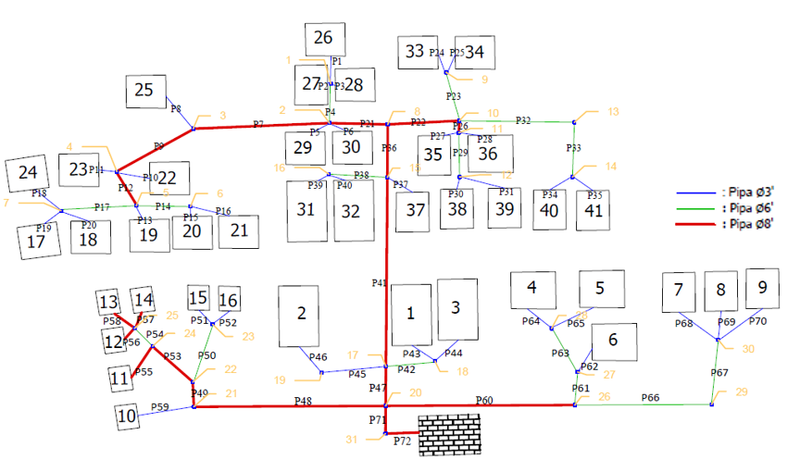
Figure 2. Pipeline Network Scheme Based on Hidraulics Calculation

Based on the calculation analysis that showed in Table 8, the speed of wastewater in all pipes is within the speed criteria limit (V) between 0.6 - 3.0 m/s, has met the applicable standards and criteria. The total length is recapitulated in table 9 below.

Table 9. Recapitulation of Pipeline Needs
Type | House Connection | Service Pipe | Main Pipe
Pipe Roughness Coefficient (n) | 0,012 | 0,012 | 0,012
Slope (S) | 0,7 - 1% | 0,7% | 0,6 – 0,7%
Speed of wastewater in pipe  V (m/s) | 0,69 – 0,82 | 0,90 | 0,93 – 1,10
Pipe Size | 4” | 6” | 8”
Length | 212.1  m | 178.8 m | 220.7 m
Criteria Standard | Compatible | Compatible | Compatible
Source : Data Analysis

3.3.3 Calculations of Complementary Building in the Piping System
Complementary buildings are supporting structures used to facilitate maintenance and improve the performance of existing drainage systems named a control tank and manhole. The control tank is used to facilitate maintenance of the pipeline in the event of a blockage which is placed at every change in the diameter of the pipe
Based on the pipeline system calculation and figure (figure 2), the needs of the control tub are calculated to be 31 units with a size of 50 x 50 x 50 cm. Placement of control tub is only installed at each pipe meeting, considering that each pipe does not exceed 50 m in length.

3.3.4 Calculation of WWTP Building Needs
WWTP buildings is placed at the lowest contour or elevation in the study area, considering the waste flow using the gravity system. Based on observations, locations that were chosen according to criteria were located on vacant land beside the river in Dusun I of Muara Lawai Village. The area of land required for the construction of WWTP depends on the number of houses served, which in this case is targeted at 41 households.
For the selection of WWTP technology at the settlement scale, it is generally chosen to use Anaerobic processing technology with consideration of efficiency. The components of the WWTP Resiential Scale are divided into two parts, namely the initial sedimentation tank, and a biofilter with anaerobic system.
Referring to the Off-Site Domestic Wastewater Treatment System Detailed Engineering Planning Guidelines (Ministry of Public Works, 2018), in conducting calculations in each tub there are design criteria that must be referred to (table 2) and several parameters that must be known and determined in advance.

Calculation of Settlement Tub
Parameters:
- Design dischrage (Q_{design}) = 67,78 m³/hr
- Peak time period =18 hours
- BOD in = 110 mg/L
- COD in = 250 mg/L
- TSS in = 120 mg/L
- SS/COD ratio (0,35-0,45) = 0,42
- Hydraulic Retention Time (HRT) = 2 hours
- Drain intervals (Ip) = 2 years
- Tub width plan (w) = 2 m
- Tub height plan (H_{tub}) = 2.5 m
- Water depth plan (H_{water}) = 2.3 m
- Freeboard height = 0,2 m

Based on calculations, the dimensions of the sedimentation tank needed are 3 meters long x 2 meters wide x 2.5 meters high. In the process of sedimentation tank management, COD can be reduced from 250 mg / l to 188.75 mg / L or by 24.5%, and BOD can be reduced from 110 mg / l to 81.43 mg / L or 26%. Drainage in the settling tub is done at intervals every 24 months with the amount of mud volume of 4.62 m³.
Control check:
T_{d} = (Vol l x w x h / Q ) x 24 hour
= ((3 x 2 x 2,2) / 67,78 m³) x 24
= 5 hours (meet the criteria)

Calculation of Aerobic Filter Tub
Parameters:
- Design discharge (Q_{design}) = 67,78 m³/hr
- Peak hour period =18 hours
- BOD in = 81,43 mg/L
- COD in = 188,75 mg/L
- Lowest temperature = 28 C
- SS/COD Ratio (0,35-0,45) = 0,42
- Drain intervals (Ip) = 2 years
- Compartment Width (w) = 2 m
- Compartment length (l) = 2.5 m
- Number of compartment = 3 pcs
- Systhesis Yield in Anaerob (Y) = 0,06

Based on the above calculation, the dimensions of each compartment in the anaerobic filter is 1.5 meters long x 2 meters wide x 2.5 meters high. Total compartments used are 3 pieces, so the total dimensions needed are length (l) 4.5 meters x width (w) 2 meters x height (h) 2.5 meters.
Control check:
T_{d} = (Vol (l x w x h) / Q ) x 24 hour
= ((4,5 x 2 x 2,5) / 67,78 m³) x 24
= 7 hours (meet the criteria)

In the process of anaerobic filter body management, COD can be reduced from 188.75 mg / L mg / l to 36.81 mg / L (meets the criteria, <100 mg / L) or 80.5% (meet the criteria, 70-90 %), and BOD can be reduced from 110 mg / l to 10.96 mg / L (meet the criteria, <40 mg / L) or 86.54%. Drainage in the anaerobic filter is done at intervals every 24 months with the amount of mud volume of 14.67 m³.

4. CONCLUSION

From the study it can be concluded that the existing condition of the wastewater sanitation infrastructure facilities in the Muara Lawai Village so far has not been feasible and safe, due to unsuitable septic tanks and 100% of households have never done desludging. This condition was not only for the MBR category, but 95.45% of the Non-MBR also did not yet have a safe and impervious septic tank. So that proper and safe sanitation is not necessarily directly proportional to the level of welfare/ economy, especially in the study area.
The appropriate wastewater management system to be implemented in Muara Lawai Village is the off-site domestic wastewater treatment system.
Provision of off-site domestic wastewater treatment system consists of Service Sub-System (Piping System) and Processing Sub-System (WWTP Building). Wastewater treatment system service coverage targeted into 41 households or 205 people with the average amount of wastewater generation (Q_{r}) 16.40 m³/day with peak discharge (Q_{peak}) of 54.82 m3/day, minimum discharge (Q_{min}) 2.33 m³ / day and infiltration discharge (Q_{inf}) 12.96 m³/day. So that the design is obtained at 67.78 m³/day.
The Piping System uses PVC waste material with a roughness value of 0.012. The total length of pipes needed for house connections (size 4") is 212.1 m, the service pipe (size 6") is 178.8 m and the main pipe (size 8") is 220.7 m. There are 31 units of control tub with 50 x 50 x 50 cm dimension installed at each pipeline meeting.
The treatment system (WWTP Building) uses anaerobic biofilter technology with the overall dimensions of the WWTP building of 7.5 x 2.0 x 2.5 m divided into 2 parts, namely the Initial Sedimentation Tank and the Biofilter Tank. Sedimentation tanks measuring 3.0 x 2.0 x 2.5 m with a residence time of 5 hours, reducing 24.50% COD of waste and 26% BOD of waste. Drain interval every 24 months with a total amount of mud 4.62 m3. The anaerobic filter is 4.5 x 2.0 x 2.5 m with 7.9 hours of residence time, reducing 80.50% COD of waste and 86.54% BOD of waste. Drain interval every 24 months with a total mud volume of 14.67 m³.

REFERENCES
A. Ristiawan, P. Purwono, and A. U. Ulya. (2019 ). Social perspective of domestic wastewater management in Entikong Lama district. Sustinere: Journal of Environment and Sustainability. DOI: 10.22515/sustinere.jes.v3i2.86.
C. Cossio, J. Norrman, J. McConville, A. Mercado, and S. Rauch. (2020). Indicators for sustainability assessment of small-scale wastewater treatment plants in low and lower-middle income countries. Environmental and Sustainability Indicators. 6. DOI: 10.1016/j.indic.2020.100028.
Central Bureau of Statistics Muara Enim. (2018). Muara Enim Regency in Figures 2018. Central Bureau of Statistics Muara Enim.
Director General of Cipta Karya Ministry of Public Works and Public Housing. (2018). Detailed Engineering Planning Guidelines for Off-Site Domestic Wastewater Treatment System (Series B). Director General of Cipta Karya Ministry of Public Works and Public Housing.
E.S. Soedjono et al. (2019). Study on Communal Wastewater Treatment Plants (CWWTPs) in Gresik, Indonesia. International Journal of Integrated Engineering.11 (2); 236-242
Environmental Service of Surabaya City Government, 2019. Technical Guidance for Hospital Waste Management. Environmental Service of Surabaya City Government
G. Tchobanoglous, F. L. Burton, and H. D. Stensel. (2003). Wastewater Engineering Treatment and Reuse, 4th Edition. Metcalf & Eddy,Inc.
J.B. Gowda, G Aishwarya and BA Kanchang Garg. (2018). Design and Working Model of a Small-Scale Wastewater Treatment Plant for Households. Journal of Applied Engineering Research. 13 (7) ; 238-240
Kementerian Pekerjaan Umum dan Perumahan Rakyat Dirjen Cipta Karya. (2018). Pedoman Teknis Pelaksanaan Sanimas IDB. Kementerian Pekerjaan Umum dan Perumahan Rakyat Dirjen Cipta Karya.
Kementerian Pekerjaan Umum dan Perumahan Rakyat Dirjen Cipta Karya. (2018). Pedoman Perencanaan Teknik Terinci Sistem Pengelolaan Air Limbah Domestik Terpusat SPAL-T Buku A. Kementerian Pekerjaan Umum dan Perumahan Rakyat Dirjen Cipta Karya.
M. L. McKenna et al.. (2017). Human intestinal parasite burden and poor sanitation in rural Alabama. American Journal of Tropical Medicine and Hygiene. DOI: 10.4269/ajtmh.17-0396.
Ministry of Environment and Forestry of the Republic of Indonesia, 2016. Regulation of the Minister of Environment and Forestry of the Republic of Indonesia No. 68 Year 2016 concerning Domestic Wastewater Quality Standards. Ministry of Environment and Forestry of the Republic of Indonesia
Ministry of Public Works. (2014). Minister of Public Works Regulation No. 01 Year 2014 concerning Minimum Service Standards for Public Works and Spatial Planning. Ministry of Public Works.
Minister For Public Works and Human Settlements. (2016). Book 3 of Off-Site Domestic Wastewater Treatment System in Residential Scale. Minister For Public Works and Human Settlements.
Minister For Public Works and Human Settlements. (2017). Regulation of the Minister of Public Works and Public Housing No. 04 Year 2017 Concerning the Implementation of Domestic Wastewater Treatment Systems. Minister For Public Works and Human Settlements.
Ministry of Villages Development of Underdeveloped Villages and Transmigration of the Republic of Indonesia. (2018). Decree of the Director General of Rural Community Development and Empowerment No. 52 of 2018 concerning the Status of Village Progress and Independence. Ministry of Villages Development of Underdeveloped Villages and Transmigration of the Republic of Indonesia.
Muara Enim Regency Government. (2012). Muara Enim Regency Regulation No. 13 Year 2012 Concerning Spatial Planning for Muara Enim Regency in 2012 - 2023. Muara Enim Regency Government.
National Team for the Acceleration of Poverty Reduction (TNP2K). (2018). Integrated Database Utilization Evaluation Report. National Team for the Acceleration of Poverty Reduction (TNP2K).
Nur, Muhammad. (2014). Analysis of Sanitation Infrastructure Needs in the Musi Riverfront. Master thesis, Universitas Sriwijaya.
Putri, Dyah Wulandari. (2017). Strategies for Developing Domestic Domestic Wastewater Infrastructure for Settlements in Specific Water Areas. Ph.D. thesis, Institut Teknologi Bandung.
S. Ichwan Prastowo. (2016). Efforts to Improve Hygiene Healthy Lifestyle by Community-Based Sanitation in the Tegalgede Karanganyar Village. Hotelier Journal Politeknik Indonesia Surakarta. 2; 27–31

