Participation of Forest Encroachers in Participatory Ecosystem Restoration Program in Dangku Wildlife Reserve, Musi Banyuasin

Indra Purnama Bahri¹, Sriati²*, Sarno³

¹Student at Environmental Management, Postgraduate Program, Sriwijaya University.

²Department of Agribusiness, Faculty of Agriculture, Sriwijaya University.
³Department of Biology, Faculty of Mathematics and Natural Sciences, Sriwijaya University.
*Corresponding Author: sriati28@gmail.com

Abstract: Conservation forest areas in Indonesia cannot be separated from threats and damage. The amount of forest area in Indonesia that continues to decrease is the reason for the importance of resolving the problems that exist in Indonesia's forest areas. One of the conservation areas that is facing serious threat is SM Dangku in Musi Banyuasin Regency. Land conversion and forest encroachment are become serious problems that have not been resolved properly. The participatory ecosystem restoration program at Dangku Wildlife Reserve is expected to be one of the right steps to restore the degraded conservation forest area. The positive impacts that came from the implementation of this program are the reduction in the number of new land clearing by the community, the increased willingness of the community to plant trees on farming land, and the decrease in the number of encroacher living in the area. In order to determine the factors that influence the success of the program, a research on the perception and participation of the forest encroacher in supporting the participatory ecosystem restoration program in Dangku Wildlife Reserve was carried out. The research was conducted using a survey method with a qualitative approach. The results showed that the participation of the forest encroacher in the participatory ecosystem restoration program was moderate, although the level of perception of the forest encroacher towards the program was quite good. One of the factors that influence this condition is that the benefits derived from the program are not in line with the expectations and needs of the encroaching communities.
Keywords: Perception, Participation, Forest Encroachers, Wildlife Reserve, Conservation Area

Abstrak (Bahasa): Kawasan hutan konservasi di Indonesia tidak lepas dari ancaman dan kerusakan. Jumlah luasan hutan di Indonesia yang terus berkurang menjadi alasan pentingnya mengatasi permasalahan yang ada di kawasan hutan Indonesia. Salah satu kawasan konservasi yang sedang mengalami ancaman serius adalah Suaka Margasatwa Dangku di Kabupaten Musi Banyuasin. Alih fungsi lahan dan perambahan kawasan hutan merupakan salah satu permasalahan serius yang belum dapat diselesaikan dengan baik. Program Pemulihan ekosistem partisipatif di SM Dangku diharapkan menjadi salah satu langkah tepat untuk memperbaiki kawasan hutan konservasi yang terdegradasi. Dampak positif yang muncul dari pelaksanaan program ini antara lain berkurangnya jumlah pembukaan lahan baru oleh masyarakat, meningkatnya kemauan masyarakat untuk menanam pohon pada lahan garapan masyarakat, serta penurunan jumlah perambah yang bermukim di dalam kawasan. Guna mengetahui faktor yang mempengaruhi keberhasilan program tersebut, maka penelitian mengenai persepsi dan partisipasi masyarakat perambah dalam mendukung program pemulihan ekosistem partisipatif di SM Dangku ini dilakukan. Penelitian dilakukan dengan metode survei dengan pendekatan kualitatif. Hasil penelitian menunjukkan bahwa partisipasi masyarakat perambah dalam program pemulihan ekosistem partisipatif tergolong sedang walaupun tingkat persepsi masyarakat perambah terhadap program tergolong baik. Salah satu faktor yang mempengaruhi kondisi tersebut yakni keuntungan yang diperoleh dari adanya program kurang sesuai dengan harapan dan kebutuhan masyarakat perambah.
Kata Kunci: Persepsi, Partisipasi,Perambah Hutan, Suaka Margasatwa, Kawasan Konservasi

1. Introduction

Indonesia's deforestation rate in the 2016-2017 period was 480,000 hectares, including the deforestation of ​​40,000 hectares in conservation areas [1]. The amount of decreasing forest area in Indonesia become the reason for the importance of managing the problems to maintaining forest area in Indonesia.
One of the conservation areas in South Sumatra Province that is currently deal with serious threats is Dangku Wildlife Reserve which is located in Musi Banyuasin Regency. The conversion and encroachment of forest areas is one of the serious problems that until now has not been able to be resolved properly.
The damage of the Dangku Wildlife Reserve area has started significantly since 2011. This can be seen from the increasing area of ​​the settlements, dry land agriculture, plantations, and open land in Dangku Wildlife Reserve at that time. This condition increased sharply in 2015 and even up to 2017.
Based on the land cover analysis by satellite imagery, total damage area of Dangku Wildlife Reserve in 2017 approximately 64% of the total area or equivalent to ​​30,715.86 hectares. The cause of damage is dominated by conversion of forest to dryland agriculture, plantations, and settlements [2]. Encroachment and conversion of conservation areas into settlements and agricultural land is one of the causes of the degradation of conservation forest areas in Dangku Wildlife Reserve.

Research location

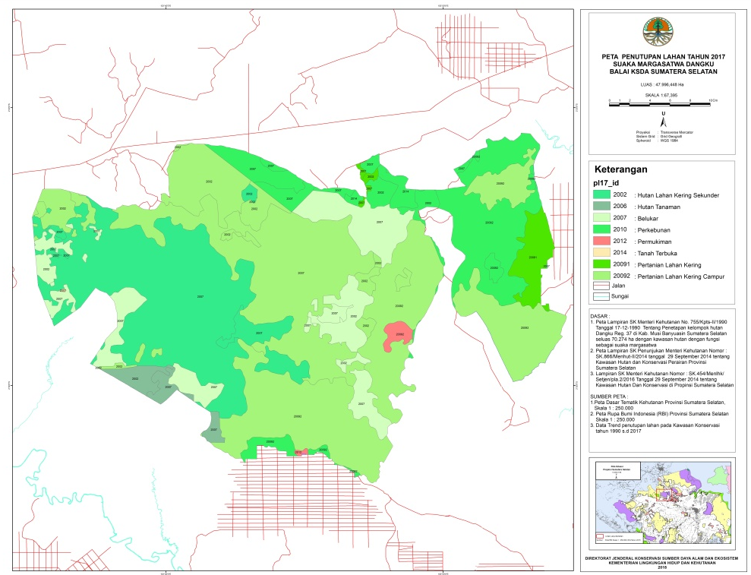

Source: Directorate General of Nature Resources and Ecosystem Conservation

Figure 1. Research location map

Ecosystem restoration is one of the right steps to restore the degraded conservation forest areas. Ecosystem restoration activities are long-term and continuous activities until the area can return to its original function.
In response to this forest encroachment problem, the efforts made by the South Sumatra Agency for Conservation of Natural Resources (BKSDA Sumsel) as the area manager are implementing a participatory ecosystem restoration program at Dangku Wildlife Reserve which has been implemented since 2017. A participatory approach in natural resource management is expected to strengthen the capacity of communities living around natural resources to manage these resources [3].
The implementation of this program is expected to be a new way and solution to the problem of encroachment on conservation forest areas as well as having an impact on the restoration of forest ecosystems and maintaining the function of conservation forest areas as well as improving the economy of the community in this area.
The participatory ecosystem restoration program through community involvement has shown positive changes, it can be seen from the decreasing of encroachment forest area in Dangku Wildlife Reserve. Based on the results of the periodic encroacher hut inventory conducted by the South Sumatra Agency for Conservation of Natural Resources (BKSDA Sumsel), there has been a 30% decrease in the number of encroacher hut after the program has been running for two years. This program needs to be continuously developed by the government so that it can be applied in other conservation areas in Indonesia that have similar problems.
In order to find out the factors that influence the program, it is important to conduct research on the perception and participation of the encroacher communities in supporting the participatory ecosystem restoration program at Dangku Wildlife Reserve.
This research is expected to provide additional information, lessons learned, suggestions and input to the government in making comprehensive policies and regulations in accordance with real conditions and needs in the field. Especially in an effort to restore conservation areas by increasing the empowerment and welfare of communities whose lives depend on forest areas.
The purpose of this study was to determine the perceptions and participation level of the forest encroachers in Sungai Petai area in the participatory ecosystem restoration program in Dangku Wildlife Reserve.

2. Material and Methods
2.1. Material and Instrument
This research is a survey research that uses respondents as a sample of a population with a questionnaire as the main tools of data collection. The population of this research is the entire community of forest encroachers who live in the Sungai Petai area, Dangku Wildlife Reserve, Musi Banyuasin Regency, South Sumatra Province. The location was chosen because it is a residential area of forest encroacher communities which is the target of a participatory forest ecosystem restoration program implemented by the South Sumatra Agency for Conservation of Natural Resources (BKSDA Sumsel).
Based on the results of the census of the encroaching communities conducted by BKSDA Sumsel in 2019 and supported by data verification in 2020, there were 170 families living in the area. The sample or target respondent in this study is the patriarch of the family who is a representation of a family where usually individuals or family members who are in a family tend to follow the opinions and decisions of a patriarch in a family.
In determining the number of samples in this study, the researcher referred to the table of the number of samples based on the table of Krejcie and Morgan with a 95% confidence level. Based on the table of Krejcie and Morgan, if the total population is 170, the research sample needed is 118 samples.
The sample selection technique uses a simple random sampling technique with the unit of analysis is the patriarch as the respondent where every respondent in the population has an equal chance of being selected as a sample. The sampling procedure uses a sampling without replacement procedure [4].

2.2. Data Analysis
In measuring the perception of the forest encroacher communities, indicators are needed to measure the perception level of the people affected by the participatory ecosystem restoration program. In an active program, a good perception is needed from the people involved, because it is the basis for forming attitudes and behavior [5]. The indicators are: 1) existence and importance of the Dangku Wildlife Reserve, 2) the existence of conservation programs and partnerships, 3) the existence of farmer groups, 4) social benefits of the program, 5) economic benefits of the program, 6) ecological benefits of the program, 7) program implementation and, 8) community dependence on Dangku Wildlife Reserve.
To measure the participation of the forest encroacher communities, indicators are needed to measure the participation level of the people that affected to the participatory ecosystem restoration program. In general, community participation can be seen from the form of participation given by the community in a tangible way (having a form) and also in the form of participation given in an intangible way (abstract) [6]. The indicators to measure the participation of the forest encroacher communities are: 1) community participation at the planning phase, 2) community participation at the implementation phase, 3) community participation at the phase of receiving benefits, 4) and community participation at the monitoring phase.
The determination of perception and participation scores is using the answers given by the respondents by making a classification or category according to the answers or opinions of the respondents to the questions given by the researcher. The scoring of each answer from the respondents is obtained using a Likert scale whose measurements are as follows:
a. Score 3 for high/good answer
b. Score 2 for moderate/fair answers
c. Score 1 for low/poor answer
After the answers from the respondents are collected, the answers to each question contained in the questionnaire are tabulated based on the score value and multiplied by the number of respondents who gave answers to the question. The results of the calculation are then multiplied by 100% to get the scoring value which is used to determine the final category value of each question used in this study. The calculation of the score of respondents' answers is carried out with the following equation below (Equations 1).

Scoring value = ((F1x1) + (F2x2) + (F3x3) x 100) (1)

Information : F1 is the frequency of respondents who answered low/poor
F2 is the frequency of respondents who answered moderate/fair
F3 is the frequency of respondents who answered high/good
The scoring value obtained from the answers to each question is used to determine the results of the assessment based on predetermined categories. Because the assessment of the respondent's answers or statements is categorized into 3 categories, the determination of the score value of the respondent's statement on each variable is divided from 100% into three levels on the criterion class (ordinal scale), the score value are: 1) less than 33.3 = poor/ low, 2) between 33.3 to 66.6 = fair/moderate, 3) more than 66.6 = good/high.

3. Result and Discussion

3.1. Perception of Forest Encroachers in The Participatory Ecosystem Restoration Program in Dangku Wildlife Reserve
The perception of the forest encroacher community as measured in this study is the view of individuals who represent a family on the implementation and receiving benefits of participatory ecosystem restoration programs in Dangku Wildlife Reserve. Community perceptions observed in this study were assessed based on 6 indicators, the indicators are: community perceptions related to the existence and importance of the Dangku Wildlife Reserve, the existence of conservation programs and partnerships, the establishment of farmer groups, social benefits from the program, economic benefits from the program, ecological benefits from the program, program implementation and community dependence level on Dangku Wildlife Reserve. Perceptions of forest encroacher communities on participatory ecosystem restoration program is shown in Table 1.
The results of the analysis show that the value of the community's perception of participatory ecosystem restoration activities in Dangku Wildlife Reserve is at 93.75 which means is in good category. This condition shows that most of the community has good knowledge and perception related to participatory ecosystem restoration activities in Dangku Wildlife Reserve. Information and knowledge about programs by involving the community to the programs is important for the community who is positioned as a managing partner to the conservation area and will affect the the success of a program.

Table 1. Perceptions of forest encroacher communities on participatory ecosystem restoration program

No. | Community Perception | Category | Number of Respondent | Percentage (%) | Score (%)
1. | Existence and importance of the Dangku Wildlife Reserve | Poor | 0 | - | 94,92
 |  | Fair | 18 | 15,25
 |  | Good | 100 | 84,75
2. | Existence of conservation programs and partnerships | Poor | 0 | - | 96,61
 |  | Fair | 12 | 10,17
 |  | Good | 106 | 89,83
3. | Existence of farmer groups | Poor | 0 | - | 95,48
 |  | Fair | 16 | 13,56
 |  | Good | 102 | 86,44
4. | Social benefits of the program | Poor | 1 | 0,85 | 94,35
 |  | Fair | 18 | 15,25
 |  | Good | 99 | 83,90
5. | Economic benefits of the program | Poor | 0 | - | 95,48
 |  | Fair | 16 | 13,56
 |  | Good | 102 | 86,44
6. | Ecological benefits of the program | Poor | 0 | - | 95,20
 |  | Fair | 17 | 14,41
 |  | Good | 101 | 85,59
7. | Program implementation | Poor | 0 | - | 93,22
 |  | Fair | 24 | 20,34
 |  | Good | 94 | 79,66
8. | Community dependence on Dangku Wildlife Reserve | Low | 2 | 1,69 | 84,75
 |  | Moderate | 50 | 42,37
 |  | High | 66 | 55,93
Total |  | 750,00
Average |  | 93,75

The perception of community to the participatory ecosystem restoration program at Dangku Wildlife Reserve is based on the hope and trust of the community in the government to be able to change the fate of the people whose lives depend on the Dangku Wildlife Reserve area.
Based on interviews conducted with the community, most people understand the importance of protecting the environment such as Dangku Wildlife Reserve area. The community felt that one of the changes that emerged after the decrease in forest stands in the environment around the community was the difficulty of finding clean water during the dry season, so that people were forced to dig deeper wells to get clean water sources. This condition is different from the earliest condition of the area at the beginning of the community living in Dangku Wildlife Reserve when there were still many stands of trees, the air was cool and it was not difficult to get clean water.
The Kemitraan Konservasi program which started in 2019 is one of the efforts by the government to increase the involvement of communities around the area to play an active role in the management of conservation areas.
Several communities have benefited from the Kemitraan Konservasi program. one of the example is the farmer groups establishment as community social interaction and also as a source of information related to Dangku Wildlife Reserve. Another social benefit is that the existence of the community in the Dangku Wildlife Reserve area was finally recognized by the village government with the farmer groups establishment with support from the local village government.
Based on observations, the community has understood the benefits that will be obtained if they are involved and support the programs being run by the government such as social, economic and environmental benefits. The community also considered that the implementation of the ecosystem restoration program was going well even though it was constrained by the lack of government budget and the minimum number of officers in the field.
Public perception and participation is still very dependent on the role of community leaders, which is strengthened by the high need for socialization and the intensity of community presence in socialization forums [7].
Most of the people said that they depend on the area because it is a source of livelihood for the people who mostly farming in Dangku Wildlife Reserve. The government must restrict public access to conservation areas in order to maintain its conservation function, but on the other hand the government must optimally ensure the lives and welfare of the people in and around the conservation areas [8].

3.2. Participation of Forest Encroachers in The Participatory Ecosystem Restoration Program in Dangku Wildlife Reserve
Community participation in this research is consists of participation, involvement, and the contribution of respondents in utilizing and supporting the implementation of the participatory ecosystem restoration program at Dangku Wildlife Reserve. Community participation in this study was measured based on 4 indicators, these indicators are community participation at the planning phase, community participation at the implementation phase, community participation at the phase of receiving benefits, and community participation at the monitoring phase.The participation of forest encroacher communities in participatory ecosystem restoration program in Dangku Wildlife Reserve is shown in Table 2.

Table 2. Participation of forest encroacher communities on participatory ecosystem restoration program

No. | Community Participation | Category | Number of Respondent | Percentage (%) | Score (%)
1. | Community participation at the planning phase | Low | 69 | 58,47 | 55,08
 |  | Moderate | 21 | 17,80
 |  | High | 28 | 23,73
2. | Community participation at the implementation phase | Low | 99 | 83,90 | 40,96
 |  | Moderate | 11 | 9,32
 |  | High | 8 | 6,78
3. | Community participation at the phase of receiving benefits | Low | 1 | 0,85 | 87,57
 |  | Moderate | 42 | 35,59
 |  | High | 75 | 63,56
4. | Community participation at the monitoring phase | Low | 109 | 92,37 | 36,44
 |  | Moderate | 7 | 5,93
 |  | High | 2 | 1,69
Total |  | 220,06
Average |  | 55,01

Based on the score, it is known that the average score of the community participation level in the participatory ecosystem restoration program is 55.01. Because the score of participation is in interval between 33.33 to 66.66, the level of community participation is classified as moderate. The highest level of community participation is in the receiving benefits phase with a score at 87.57 and the lowest participation at the monitoring phase with a score at 36.44. Although the level of community perception of the forest is high, the level of community participation in forest management is in the moderate category and tends to be low. Allegedly there are other factors that affect the level of community participation in conservation forest management [9].
Community participation at the monitoring phase is the lowest participation from all form of participation. This condition occurs due to monitoring activities are usually carried out together with forestry officers and require a lot of energy and time. If people participates in monitoring activities, they must temporarily leave their works for farming.
In contrast to community participation at the monitoring phase, the benefit-receiving phase shows a high participation from community. Village community participation occurs due to incentives or subsidies from the government for each activity (such as procurement of materials and wages) [10].
Related to the perception and acceptance of benefits, the existence of incentives directly forms an understanding in the community where they are willing to work or participate only if incentives are available.
Communities in the research location generally get many benefits from participatory ecosystem restoration program at Dangku Wildlife Reserve. The direct benefit obtained for community is the availability of work wages that can be obtained by tree planting activities. In addition, other benefit received by the community who participates in forest management activities is fruit plant seedlings that can be planted in community farmland.
Based on the results of data analysis, community participation at the receiving benefits phase is a form of participation that has the highest value because any form of benefit that can be obtained by the community will be well received by the community, especially those in need.

4. Conclusion
The perception of forest encroachers in Dangku Wildlife Reserve towards the participatory ecosystem restoration program at Dangku Wildlife Reserve is in good category. While the level of participation of forest encroachers to the Dangku Wildlife Reserve participatory ecosystem restoration program is in the moderate category.
This condition shows that although the community has a good perception of the program, it does not have a positive impact on the participation from forest encroacer in the participatory ecosystem restoration program at Dangku Wildlife Reserve. This condition occurs because the expectations of the forest encroacher does not fulfilled by participating into the program, and in the end can affect community participation on participatory ecosystem restoration program at Dangku Wildlife Reserve.

Reference
[1] KLHK, “Status Hutan dan Kehutanan Indonesia 2018”. Jakarta: Pusat data dan Informasi KLHK, Manggala Wana Bakti. 2018.
[2] Purnasari, Salaki, L. D., Bahri, I. P., Purnama, O. F., Kharis, T., dan Syarifah, “Mencari Jalan Tengah: Pembelajaran dari Suaka Margasatwa Dangku”. BKSDA Sumatera Selatan. 2020.
[3] Nurrochmat, D. R., Darusman, D., Ekayani, M., “Kebijakan Pembangunan Kehutanan dan Lingkungan”. Bogor (ID): IPB Press. 2016.
[4] Morissan, M. A, “Metode Penelitian Survei”. Jakarta: Kencana Prenada Media Group, 2012.
[5] Irawan, A., Iwanuddin, Halawane, J.E. & Ekawati, S., “Analisis persepsi dan perilaku masyarakat terhadap keberadaan kawasan KPHP Model Poigar”. Jurnal Penelitian Sosial dan Ekonomi Kehutanan, 14(1), 71–82. 2017.
[6] Laksana, N. S., “Bentuk-bentuk Partisipasi Masyarakat Desa dalam Program Desa Siaga di Desa Bandung Kecamatan Playen Kabupaten Gunung Kidul Provinsi Daerah Istimewa Yogyakarta”. Kebijakan dan Manejemen Publik, Vol. 1 (1), 56–67. 2013.
[7] Purwandari, A. W., dan Mussadun, “Studi Partisipasi Masyarakat Pada Pelaksanaan Musyawarah Perencanaan Pembangunan Kelurahan di Kelurahan Semanggi Kota Surakarta”. Jurnal Pembangunan Wilayah dan Kota. Volume 11 (4): 377-390 Desember 2015. Biro Penerbit Planologi Undip. 2015.
[8] Prayitno, D. E., “Kemitraan Konservasi Sebagai Upaya Penyelesaian Konflik Tenurial dalam Pengelolaan Kawasan Konservasi di Indonesia”. Jurnal Hukum Lingkungan Indonesia, Vol. 6, No. 2, 2020: Halaman 184 – 209. 2020.
[9] Hakim, A. M., dan Darusman, D., “Persepsi, Sikap, dan Partisipasi Masyarakat dalam Pengelolaan Hutan Mangrove di Wonorejo, Surabaya, Jawa Timur”. Bonorowo Wetlands 5 (2): 85-93, December 2015 ISSN: 2088-110X, E-ISSN: 2088-2475. DOI: 10.13057/bonorowo/w050204. 2015.
[10] Rochmayanto, Y., Frianto, D., Nurrohman, E., “Analisis Partisipasi Pada Program Hutan Kemasyarakatan (Studi Kasus Di Koto Panjang, Riau)”, Jurnal Penelitian Sosial & Ekonomi Kehutanan Vol. 3 No. 3 September 2006, Hal. 175 – 189. 2006.

