SUBMISSION LETTER

Article title:

**Assessment of Seine Net Selectivity in Lake Maninjau, Agam Regency, West Sumatra - Indonesia**

Name of the authors: **Dea Amelia, Farhan Ramdhani*, Nelwida, Nurhayati, Lisna, Fauzan Ramadan**

Hereby I would like to submit the manuscript entitled “Assessment of Seine Net Selectivity in Lake Maninjau, Agam Regency, West Sumatra - Indonesia”

This manuscript was not submitted or published to any other journal. The authors declare that the manuscript is an original paper and contain no plagiarized text. Plagiarism in all its forms constitutes unethical publishing behavior and is unacceptable. Where an article, for example, is found to have plagiarized other work or included third- party copyright material without permission or with insufficient acknowledgement, or where the authorship of the article is contested, the right to take action including, but not limited to: publishing an erratum or corrigendum (correction); retracting the article; taking up the matter with the head of department or dean of the author's institution and/or relevant academic bodies or societies; or taking appropriate legal action will be conducted.

Submitting the same manuscript to more than one journal concurrently constitutes unethical publishing behavior and is unacceptable. Articles may only be withdrawn if they have not been formally published. To withdraw an article, the authors must write a clear and concise letter with an in-depth explanation as to why the manuscript needs to be withdrawn. The letter must be signed by all authors. The journal maintains the right to withdraw an article due to the presence of plagiarism, fraudulent use of data or violations of other ethical codes.

Authors should not submit articles describing essentially the same research to more than one journal. All authors declare that they are not currently affiliated or sponsored by any organization with a direct economic interest in subject of the article. My co-authors have all contributed to this manuscript and approve of this submission.

Corresponding author

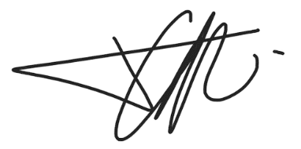

Farhan Ramdhani

Date : 29 November 2024